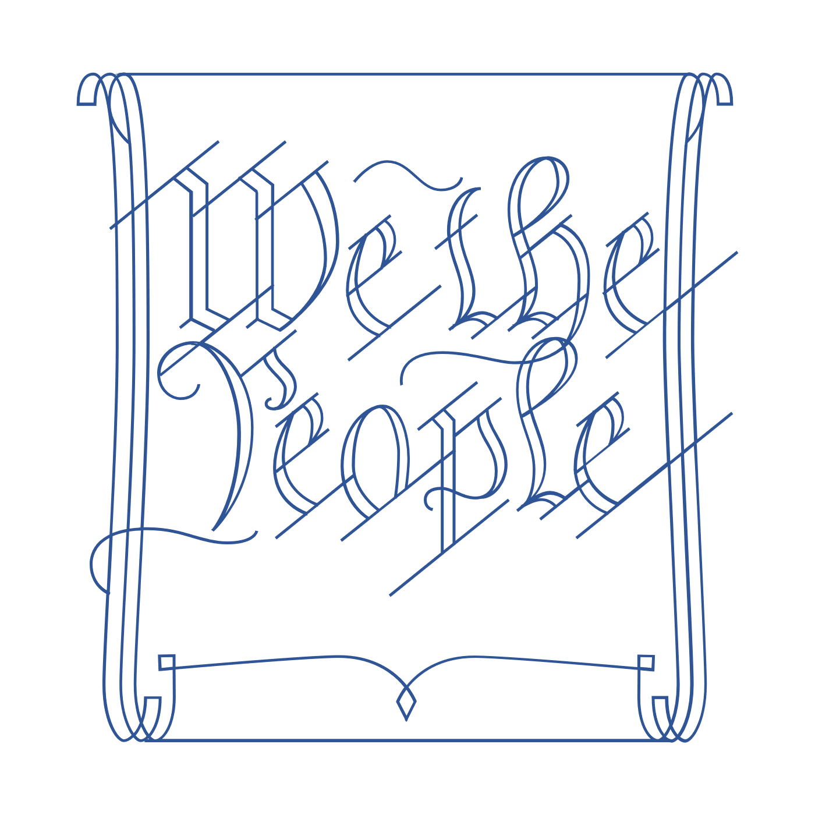
Scholar Exchange: Ratification and The Federalist Papers
Introductory Level
Class Outline and Worksheet

INTERACTIVE CONSTITUTION RESOURCES

- Resources for Article VII - Ratification Debates

OVERVIEW

Part I: Introduction: The Ratification Fight and Key Players--Federalists and Anti-Federalists
Part II: The Ratification Story--Beginning with the Dissenters at the Constitutional Convention
Part III: The Ratification Fight State-by-State
Part IV: The Anti-Federalists
Part V: The Federalists

QUESTIONS TO CONSIDER

- When was the Constitution completed and signed, and what was the process for deciding whether to adopt it?
- What is ratification?
- Who were the Federalists, and what were some of the key arguments in favor of the new Constitution?
- Who were the Anti-Federalists, and what were some of the key arguments against the new Constitution?
- What were The Federalist Papers, who wrote them, and what did they say?
- How did the ratification process play out at the state level, and how did the supporters of the new Constitution win the battle?
- What role did compromise play in the ratification of the U.S. Constitution?
- What is the relationship between the ratification process and key constitutional principles like popular sovereignty and federalism?

BIG IDEA

When the Constitution was signed by the Framers at the Constitutional Convention on September 17, 1787, it was a mere proposal. The Framers understood that the people themselves still had to accept this new Constitution. Acting through their state ratifying conventions, the American people had to decide whether to give the Constitution life—whether to say “yes” or “no.”

PART I. INTRODUCTION: THE RATIFICATION FIGHT AND KEY PLAYERS
What happened on September 17, 1787?
What is “ratification”?
Why was the proposed Constitution a surprise to the American people?
What was the term for people who supported the Constitution? What were some common traits among the Constitution’s supporters?
What was the term for people who were opposed to ratifying the Constitution?
NOTES:

PART II. THE RATIFICATION STORY--BEGINNING WITH THE DISSENTERS AT THE CONSTITUTIONAL CONVENTION
Who were the three Dissenters at the Constitutional Convention?
Elbridge Gerry
Name one reason the Dissenters gave for not signing the Constitution
BONUS QUESTION: What made the Constitutional Convention particularly smelly?

NOTES:

PART III. THE RATIFICATION FIGHT STATE-BY-STATE
Name one state that ratified the Constitution unanimously.
Name a state where there was a struggle to ratify the Constitution.
What promise did the Federalists make in order to get 9 states to ratify the Constitution?
What was this deal known as?
The Compromise.
What happened on June 21, 1788?
What happened on December 15, 1791?

NOTES:

PART V: THE ANTI-FEDERALISTS
Who were the Anti-Federalists, and what did they care about? Give one or more details.
What were the Letters from Brutus, and who wrote them?

PART V: THE FEDERALISTS
Who were the Federalists, and what did they care about? Give one or more details.
What were The Federalist Papers, and who wrote them?
NOTES:

