THE 27 AMENDMENTS TO THE UNITED STATES CONSTITUTION

Throughout American history, “We the People” have amended our Constitution 27 times—transforming it in important ways.
Through the Article V amendment process, we often make it a “more perfect” document. In this activity, you will learn more about key periods of constitutional change and explore the 27 amendments to the Constitution.
How well do you remember the 27 amendments? Write the big ideas of each amendment on the corresponding blank cards provided, then cut out the cards, shuffle them, and play a matching game.

First Amendment  1791 | Second Amendment  1791 | Third Amendment  1791 | Fourth Amendment  1791

Fifth Amendment  1791 | Sixth Amendment  1791 | Seventh Amendment  1791 | Eighth Amendment  1791

Ninth Amendment  1791 | 10th Amendment  1791 | 11th Amendment  1795 | 12th Amendment  1804

13th Amendment  1865  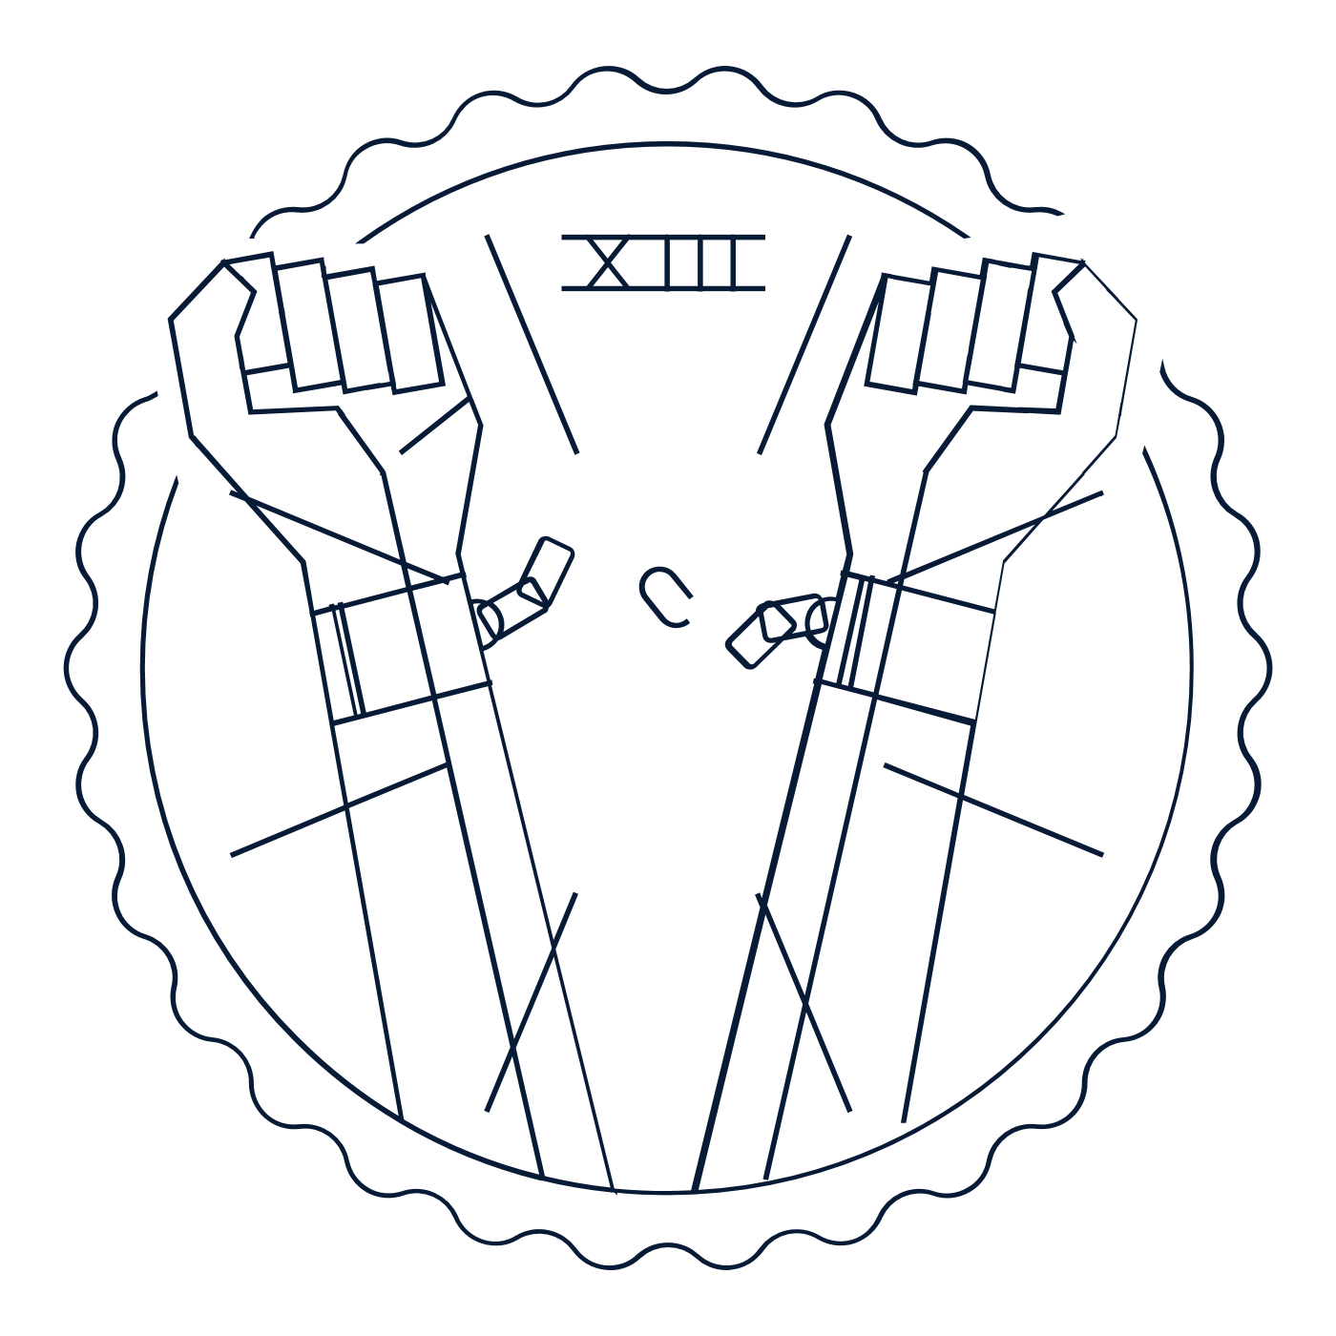 | 14th Amendment  1868 | 15th Amendment  1870 | 16th Amendment  1913

17th Amendment  1913 | 18th Amendment  1919 | 19th Amendment  1920 | 20th Amendment  1933

21st Amendment  1933 | 22nd Amendment  1951 | 23rd Amendment  1961 | 24th Amendment  1964

25th Amendment  1967 | 26th Amendment  1971 | 27th Amendment  1992

