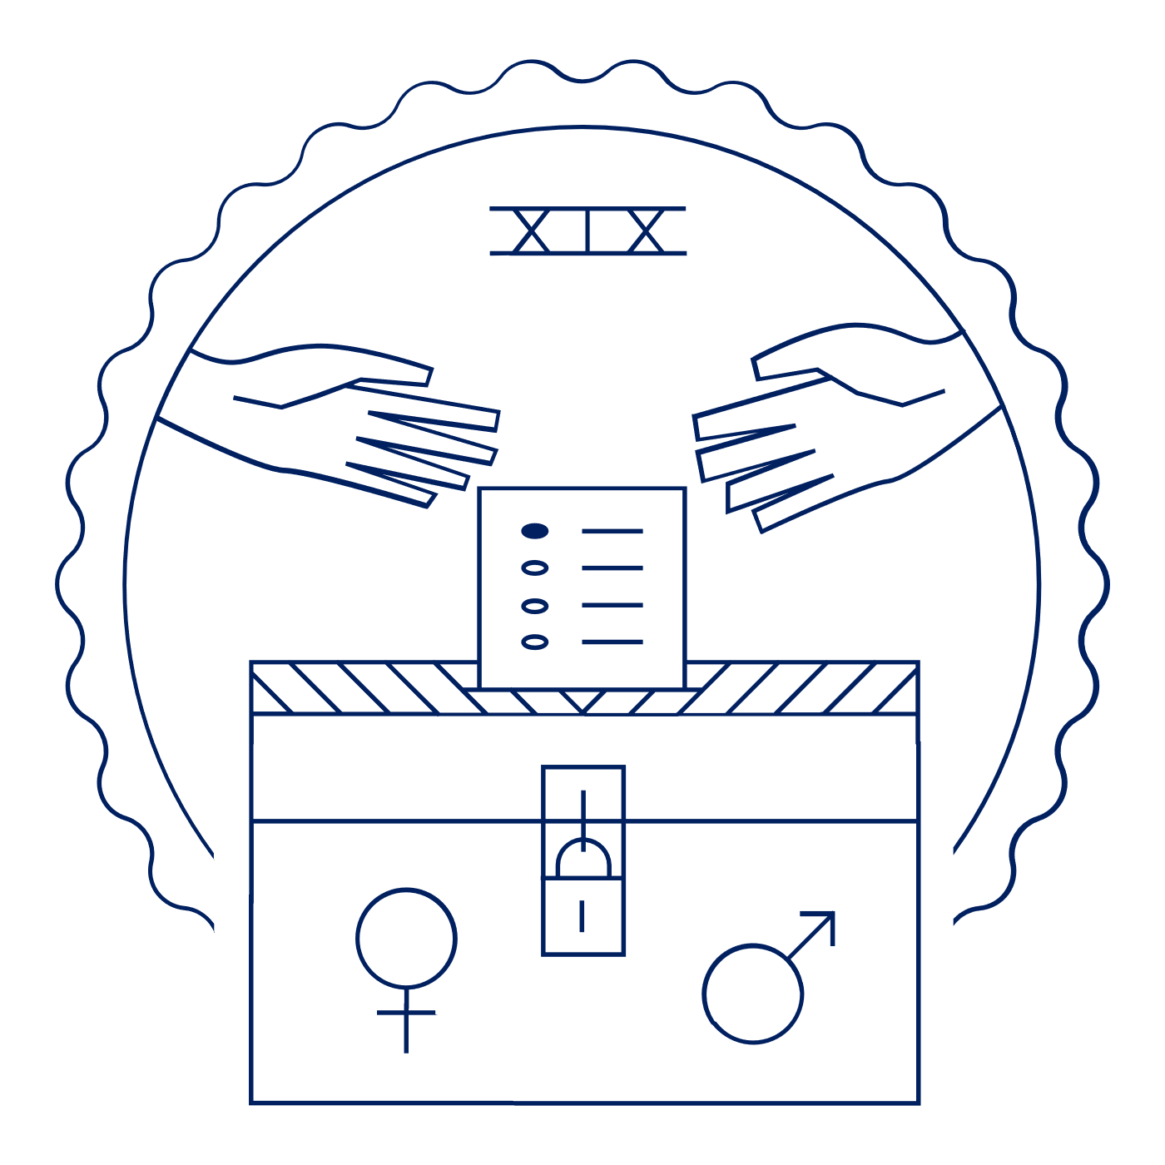
Scholar Exchange: Nineteenth Amendment
Introductory Level
Class Outline and Worksheet

INTERACTIVE CONSTITUTION RESOURCES

- Resources for the 19th Amendment

OVERVIEW

Part I. A Brief Introduction to the 19th Amendment
Part II. History of Women’s Suffrage Before the Civil War
Part III: History of Women’s Suffrage After the Civil War
Part IV: Final Push for a Women’s Suffrage Amendment
Part V: Story of Women’s Suffrage After Ratification

QUESTIONS TO CONSIDER

- What did the Nineteenth Amendment say, and who were some of the key figures who made it a reality?
- What was the Seneca Falls Convention? What was the Declaration of Sentiments? And what did this key moment suggest about the roots of the women’s rights movement in the mid-1800s?
- What were the constitutional arguments advanced by those supporting the women’s vote and those advanced by those opposing it?
- How was the Nineteenth Amendment story an example of federalism in action?
- What did the Nineteenth Amendment settle when it was ratified, and what work remained in the decades ahead?

BIG IDEA

With the Nineteenth Amendment, women won the right to vote. This Amendment grew out of decades of advocacy by the suffragists and their allies. Women’s suffrage began out West in the late 1800s and eventually spread to the rest of the nation—culminating in the ratification of the Nineteenth Amendment in 1920. Even so, it would take many more years—and the hard work of the Civil Rights Movement—to extend voting rights on the ground to all women, including women of color.

NOTES:

PART ONE
What is at least one thing that is significant about the text of the 19th Amendment?

PART TWO: WOMEN’S SUFFRAGE BEFORE THE CIVIL WAR
What is one example of a restriction on voting during the Founding era?
What was one right that women were fighting for, other than suffrage?
What was the Seneca Falls Convention?

PART TWO: WOMEN’S SUFFRAGE AFTER THE CIVIL WAR
How did the ratification of the 14th and 15th Amendments impact the women’s suffrage movement?
What was the “New Departure”?

PART THREE: FINAL PUSH FOR THE WOMEN’S SUFFRAGE AMENDMENT
How did women’s suffrage progress at the state level?
How did women’s suffrage progress at the national level?
What impact did World War I have on the women’s suffrage movement?

PART FOUR: STORY OF WOMEN’S SUFFRAGE AFTER RATIFICATION
Provide information on at least one question or issue that needed to be addressed after the ratification of the 19th Amendment.

QUESTIONS AND NOTES:

