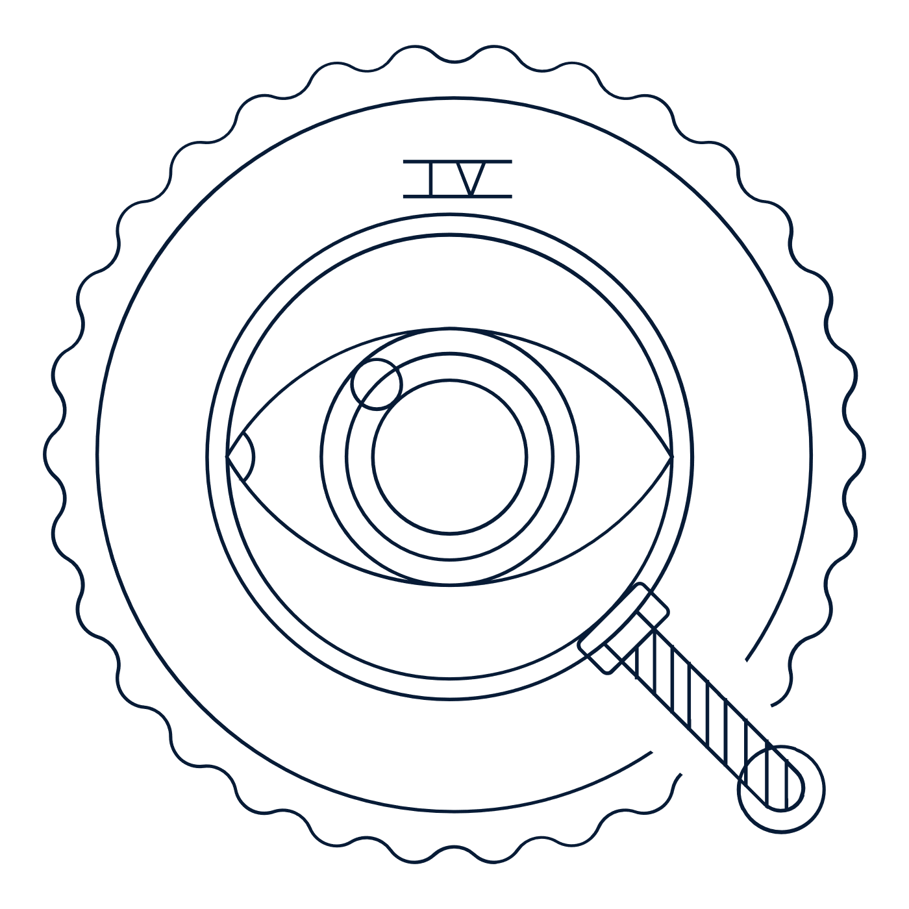
Scholar Exchange: Fourth Amendment
Briefing Document

INTERACTIVE CONSTITUTION RESOURCES

- Resources for the Fourth Amendment

INTRODUCTION

Big Questions

- Why did the Framers put the Fourth Amendment in the Bill of Rights?
- What was the Founding generation’s vision for the Fourth Amendment and its protection against unreasonable searches and seizures?
- When does the Fourth Amendment allow the government to search you or seize your property?
- When is a government’s search of seizure “reasonable”?
- How has the Supreme Court interpreted the Fourth Amendment over time? And how has it dealt with the challenge of shaping the Fourth Amendment’s meaning in light of new technologies, especially as it applies to public schools?

Big Idea

Before the government can search your home or seize your property, it needs a good reason. This is the big idea behind the Fourth Amendment’s warrant requirement. The government needs particularized suspicion—a reason that’s specific to each suspect—before it can get a warrant. Broadly speaking, our Constitution says that the police should only be able to invade a person’s rights to privacy, property, or liberty if they have a specific reason to think that that specific suspect has done something wrong.

INTRODUCTION TO THE CONSTITUTION’S TEXT

Let’s begin—as we always do when interpreting the Constitution—with the Constitution’s text:

“The right of the people to be secure in their persons, houses, papers, and effects, against unreasonable searches and seizures, shall not be violated, and no Warrants shall issue, but upon probable cause, supported by Oath or affirmation, and particularly describing the place to be searched, and the persons or things to be seized.”

Looking at the Fourth Amendment’s text, it’s worth noting a couple of quick things.

First, this amendment can be broken down into a few different parts:

- Which things are protected: persons, houses, papers, and effects.
- What are “effects”? They’re our stuff.
- Against what: unreasonable searches and seizures by the government.
- Who’s the government here? Usually police officers.

So, this is the amendment that most involves our interactions with police officers as part of our daily lives

Finally, we have the warrant requirement. So, the Fourth Amendment places restraints on the government any time it searches or seizes a person or her property. True to the Amendment’s text, the government’s search or seizure must be reasonable.

That’s the Fourth Amendment’s core protection.

And finally, the warrant requirement itself ensures that searches and seizures are generally cleared in advance by a judge. To get a warrant from a judge, the government must show “probable cause.”

“Probable cause” simply means a certain level of suspicion of criminal activity—to justify a particular search or a particular seizure. Its suspicion that attaches to a particular person, place, or item—for instance.

In the end, when thinking about the Fourth Amendment, we often start with a simple question: Can they do that?

Can police officers stop me on the street? Can they search my car, my desk, my nightstand, or my email? Can they look at who I’ve called, where I’ve been, or what I’ve written?

Big Idea

Before the government can search your home or seize your property, it needs a good reason. This is the big idea behind the Fourth Amendment’s warrant requirement. The government needs particularized suspicion—a reason that’s specific to each suspect—before it can get a warrant. Broadly speaking, our Constitution says that the police should only be able to invade a person’s rights to privacy, property, or liberty if they have a specific reason to think that the suspect has done something wrong.

Carpenter v. United States (2018) Hypothetical: Can the government track you 24 hours a day, 7 days a week, for an entire month, using your cell phone data and location information?

FOUNDING STORIES OF THE FOURTH AMENDMENT

Let’s move on to discuss some of the key Founding Stories here — starting with James Otis and his importance to the Founding generation.

James Otis

The year is 1761, and the city is Boston.

The British Empire, as a result of the French Indian War that was ongoing, started more vigorous enforcement of long-standing anti-smuggling acts—known as the “Navigation Acts” in order to collect revenue from the colonies under acts like the “Molasses Act of 1733.” Thus, the empire ended the policy of “Salutary Neglect” which had been in effect since the 17th century in which the empire turned a “blind eye” to illegal trading, because of the massive war debt.

King George then used royal officials in the colonies to crack down on these tax evaders and proclaimed colonial smugglers with the use of so-called “Writs of Assistance.” Writs of Assistance gave royal officials (here, customs officials) “free range” to break into the homes of colonists to search for evidence . . . anytime, anywhere, and for any reason.

Enter James Otis. Otis was a prominent Boston lawyer and a patriot. (He in fact had the high position of Advocate General of the Admiralty Court in 1760 before he quit when the Massachusetts’ governor would not make Otis’ father the colonies’ chief justice)

Otis publicly denounced the Writs of Assistance, stating that the unregulated search of people’s houses and private papers violated the fundamental rights of all free people. (Particularly, Otis referred to the “rights of man,” and so while he used the English unwritten constitution and common law, he also invoked natural rights and even noted his support for abolition of slavery). Here’s James Otis on the Writs of Assistance: “It is a power that places the liberty of every man in the hands of every petty officer.”

Otis lost the battle. But he wasn’t forgotten. Many years later, John Adams—who heard Otis’s argument—said that it was “the first scene of the first act of opposition to the arbitrary claims of Great Britain. Then and there the child of Independence was born.” It was Otis’s battle against the unregulated search of people’s houses and private papers that helped inspire our Fourth Amendment years later.

More of the Founding Context

Like Otis, James Madison and the Founding generation were primarily concerned about general warrants. These warrants had allowed royal agents to conduct broad searches without limits and thus giving them arbitrary power to wield at disfavored colonists. These types of searches violate fundamental liberties and make it easy to crack down on political dissenters.

Because of this, state constitutions banned general warrants even before the U.S. Constitution itself. For instance, the Virginia Declaration of Rights banned “general warrants, whereby an officer or messenger may be commanded to search suspected places without evidence of fact committed.” Several state constitutions—including those in Massachusetts and Pennsylvania—opened with a Preamble similar to the first clause of the Fourth Amendment, declaring the right of the people to be free from oppressive search and seizures.

The message here was simple. Warrants were often the instruments of tyranny. They were things to be resisted and limited. The Founding generation knew that these sorts of protections were important to everyone, and so they wrote them into the Fourth Amendment.

Again, to put it simply, at its core, the Fourth Amendment enshrines the following principle in the Constitution: Before the government can search your home or seize your property, it needs a good reason.

KEY FOURTH AMENDMENT CASES

We’ve already discussed the Constitution’s text and history. Now, let’s turn to how the Supreme Court has approached the Fourth Amendment over time. In particular, we’re going to look at three cases involving the Fourth Amendment and phones—one in the 1920s, one in the 1960s, and one just a few years ago.

But first, so that we’re all on the same page, let’s begin with the basic legal framework that the Supreme Court uses to analyze these cases. Again, let’s remember the Fourth Amendment’s big idea: Before the government can search your home or seize your property, it needs a good reason.

That sounds simple, right? But how does the Supreme Court apply the Fourth Amendment in specific cases today?

It starts by asking a basic question: Was there a search or a seizure? Usually, the answer is pretty clear.

- Entering someone’s home to look for evidence is a search.
- But passively observing someone in plain view in public is not.

In the same way, what’s a seizure?

- When the government restrains someone or takes her property, there’s a seizure.
- When the government doesn’t, there isn’t.

But most of the time, in the cases that the Supreme Court hears, it’s a closer call. And we’ll discuss some of the nuances in a little bit. For now, let’s keep it simple, though. If there’s no search or seizure, then there’s no Fourth Amendment violation. End of story.

However, if there’s a search or a seizure, then the Court must ask another key question: Was that search or seizure reasonable?

Generally, the police need to go to a judge and secure a warrant supported by probable cause before searching a home or seizing property.

Probable cause requires a “fair probability” that, for instance, the relevant evidence of a crime will be found in the place (or thing) to be searched.

This is less than the ordinary standard of proof in judicial proceedings—so, it doesn’t require that it be “more likely than not” that this is true.

Again, the big idea behind the warrant requirement is the need for particularized suspicion.

No general warrants! If the police don’t go to a judge and get a warrant first, then the search or seizure is usually considered unreasonable.

But does a police officer always need a warrant to search you, your house, or your stuff? No! The police must normally get a warrant, but there are times when a warrant is not required. The police may search you during an arrest. Or at a check point.

Or when there’s imminent danger that someone might be hurt, a suspect might run away, or evidence might be destroyed—as in a drug raid.

If there’s a Fourth Amendment violation, what happens next?

Generally, courts will apply what’s known as the exclusionary rule—throwing out evidence in a criminal trial that the police got by violating the Fourth Amendment. This is meant as a check on police abuses. But again, there are exceptions. For example, if police officers were acting in good faith and made a mistake.

With some of those basics out of the way, let’s walk through a series of cases that will help us think through some important Fourth Amendment issues.

Olmstead v. United States (1928)

Let’s begin with the Olmstead case—one of the most important early cases on the Fourth Amendment.

For much of the Supreme Court’s history, the Court held that you needed to show that the government had physically trespassed on your property—for instance, it had actually walked onto your property, entered your house, or touched an object that belonged to you—in order to win a Fourth Amendment case.

Olmstead took place in 1928 during the height of Prohibition—the war on alcohol. The government was wiretapping the phones of suspects in order to enforce Prohibition—in other words, to catch people that they thought were selling alcohol. In Olmstead, federal agents were investigating Roy Olmstead for running an illegal liquor business. Without a judicial warrant, they installed “wiretaps” on the phone lines leading to the office of the suspected illegal business, as well as to Olmstead’s home and to those of his suspected accomplices. The wiretaps were installed on the parts of the lines in the public street and in the basement of the office building. Able to listen to the suspects’ phone conversations, the agents uncovered evidence that Olmstead was selling liquor.

Olmstead argued that this violated the Fourth Amendment. He lost.

The Supreme Court ruled that the government’s use of wiretaps had not violated the Fourth Amendment. For the Court, the Fourth Amendment required an actual physical examination of one’s person, papers, physical effects, or home—not their mere conversations. In this view, the wiretapping in this case wasn’t a search because it didn’t involve a trespass on the suspects’ property and because it had not seized any papers or effects from the suspects. It only enabled the agents to listen in on conversations.

In the Court’s majority opinion, Chief Justice Taft—the former President-turned-Supreme-Court-Justice—made a simple argument: No physical trespass, no constitutional violation.

The Founding generation linked Fourth Amendment protections to property rights, and Taft argued that the Court should do the same.

However, in a powerful separate opinion, Justice Brandeis dissented. He discussed the Founding generation, arguing that the Supreme Court must read the Fourth Amendment in such a way that it protected at least as much privacy as in the colonial era. Here’s Brandeis:

“Progress of science and espionage is not likely to stop with wiretapping. Ways may some day be developed by which the government without physically intruding into the home may extract secret records and introduce them into Court.”

Brandeis continued:

“At the time of the Framing, a far smaller intrusion—the general warrants that sparked the American Revolution—were held to be unconscionable violations of liberty. Can it be that the Constitution does not afford protections against similar invasions in light of new technology?”

In other words, Brandeis challenged the Court to translate old principles to meet the challenges of new contexts. The Supreme Court eventually embraced Brandeis’s insight, but in a way that ultimately risked undermining the Fourth Amendment’s broader purpose.

To understand how, let’s fast forward to 1967 and consider Katz v. United States.

Katz v. United States (1967)

The Katz case involved the government listening in on a conversation in a public phone booth.

Acting on a suspicion that Katz was transmitting gambling information over the phone to clients in other states, federal agents attached an eavesdropping device to the outside of a public phone booth used by Katz. Based on recordings of his end of the conversation, Katz was convicted for illegal gambling.

Katz argued that the government violated the Fourth Amendment by listening in on his conversation. The Supreme Court agreed. And in the process, it overruled Olmstead and its requirement of a physical trespass.

The Court ruled that Katz was entitled to Fourth Amendment protection for his conversations and that a physical intrusion into the area he occupied was unnecessary to bring the Amendment into play. The Court reasoned that Fourth Amendment protections were not limited to an individual’s property. As the Court said in Katz, the Fourth Amendment protects people, not places.

Although a public phone booth is a public space rather than private property, individuals have a strong expectation that such conversations will not be overheard. And because Katz had taken actions like closing the phone booth door behind him before making his call—steps to protect his privacy—the Court held that he reasonably expected that his call wouldn’t be monitored without a warrant.

In an influential separate opinion—a concurrence—Justice Harlan laid out a new test. The Court would eventually adopt it as its preferred approach to Fourth Amendment cases. (This shows just how influential a concurrence or even a dissent can be!)

For Harlan, Fourth Amendment protections apply whenever the individual has a “reasonable expectation of privacy.”

Harlan’s Katz test has two components:

(1) Did the individual have a subjective expectation of privacy (e.g., did they seek to preserve the information as private); (2) If so, was this expectation of privacy one that society would recognize as reasonable?

This test is important because it says that Fourth Amendment privacy interests are not exclusively tied to an individual’s property rights. Under Katz, police activity may constitute a search even if it takes place in public or does not interfere with your property. On this view, the Fourth Amendment test should be whether people have a subjective expectation of privacy that society is prepared to accept as reasonable.

However, scholars have long criticized Harlan’s test. And it’s easy to see why.

As technology advances, pervasive surveillance becomes increasingly possible. This shapes society’s expectation of privacy. With fancier technology and more government surveillance, society’s expectation of privacy goes down. And under Harlan’s test, as society’s expectation of privacy goes down, the Fourth Amendment’s constitutional protections go down, too. This is a problem for anyone looking for a robust set of Fourth Amendment protections—especially in the digital age. And it is as well for scholars and judges who look to the original meaning of the Fourth Amendment.

Third Party Doctrine Cases:

In the 1970s, the Supreme Court decided two cases—U.S. v. Miller (1976) and Smith v. Maryland (1979)—that provided an additional gloss on the reach of our reasonable expectation of privacy. (The Court moved forward with Harlan’s test and applied it to other areas, like what happens when we give data to a third party)

However, these decisions limited the Fourth Amendment’s reach. They also pulled back from the first major Fourth Amendment case, Boyd v. United States from 1886. It held that a compulsory production of private business papers was a "search and seizure" under the Fourth Amendment.

The bottom line?: These cases said that when we surrender our information or data to someone else—for instance, a private company—we abandon all reasonable expectations of privacy in that information or data.

U.S. v. Miller (1976)

In Miller, the Court said that when we surrender our bank records to a bank, we lose our expectation of privacy in those bank records. And therefore, a bank is free to turn my records over to the government even without a warrant.

Smith v. Maryland (1979)

In Smith v. Maryland, the Court said that when we use the telephone and a pen register records the numbers that we dial, we abandon an expectation of privacy in the phone numbers that we call.

As with the bank in Miller, we’ve surrendered this information to another party—our phone company—and therefore the government doesn’t need to get a warrant to get access to the records of our phone calls.

Together, these cases establish (what’s known as) the “third party doctrine”: When the government tries to obtain “third-party” information—such as bank records or pen registers—that is generally not a search for Fourth Amendment purposes. And therefore, the government doesn’t need to get a warrant before getting access to that information.

These two cases are central to the Carpenter case. A key question there is whether when we voluntarily surrender our cell phone geolocational records to cell phone companies, the Court should apply the logic of Miller and Smith v. Maryland and conclude that there’s no reasonable expectation of privacy, no search, and no warrant required.

New Technology Cases:

Finally, the Court has recently decided two important Fourth Amendment cases—both involving new technology.

These cases raise a difficult question: How do we apply the Fourth Amendment’s text and traditional Fourth Amendment principles to the new challenges of the digital age? While Miller and Smith v. Maryland limited the reach of the Fourth Amendment’s protections, these new cases pointed in the opposite direction—increasing Fourth Amendment protections in the digital age.

HYPOTHETICAL REVOTE AND CARPENTER V. UNITED STATES (2018)

Now that we’ve covered the Fourth Amendment’s text, history, and cases. It’s time to revote on Carpenter. Moderator asks the students to vote on the Carpenter question again.

Can the government track you 24 hours a day, 7 days a week, for an entire month, using your cell phone data and location information? (Carpenter v. United States, 2018)

The Supreme Court wrestled with the challenge of translating the Fourth Amendment’s key protections in light of new technology like cell phones in a recent case—Carpenter v. United States.

As many of you probably know, cell phones transmit geolocational data—data telling the cell phone companies (and, potentially, the police—if they get access to the phone itself or to the data) where we are at any given time. With enough of this data, the government can even retrace our movements over long periods of time.

In Carpenter, police officers arrested four men in a string of armed robberies. One of these men confessed. He gave his cell phone to the FBI and gave the agents the cell phone numbers of many of his accomplices. The FBI then used this information—and the suspect’s call log—to get the cell phone records of many other suspects.

Importantly, the government didn’t get a warrant. Instead, they requested this data through a national law—the Stored Communications Act. By using this law, the government only had to say that the cell phone records were relevant to a legitimate criminal investigation. This “relevance” standard is lower than the test for getting a warrant—known as “probable cause.”

The police eventually arrested Timothy Carpenter. And he was convicted and sentenced to 116 years in prison.
Carpenter asked the question: Can they do that? Can the FBI gain access to my cell phone records without a warrant?

In a closely divided 5-4 decision—authored by Chief Justice John Roberts—the Supreme Court ruled that the practice of acquiring cell phone location information from wireless service providers is a Fourth Amendment search because it violates a person’s “legitimate expectation of privacy in the record of his physical movements.”

The Court also ruled that accessing those records without a warrant violates the Fourth Amendment. As we learned, normally, this information would be covered by the “third party doctrine,” holding that individuals do not have an expectation of privacy in information they give to someone else. But the Court held that cell phone location data, aggregated over time, paints such a detailed picture of an individual’s life that it amounts to a Fourth Amendment search.

The majority acknowledged that the Fourth Amendment protects not only property interests, but also reasonable expectations of privacy. Expectations of privacy in this age of digital data do not fit neatly into existing precedents, but tracking a person’s movements and location through extensive cell-site records is far more intrusive than the prior precedents might have anticipated.

The Court declined to extend the “third-party doctrine” to cell-site location information. One consideration in the development of the third-party doctrine was the “nature of the particular documents sought,” and the level of intrusiveness of extensive cell-site data weighs against application of the doctrine to this type of information. Additionally, the third-party doctrine applies to voluntary exposure, and while a user might be abstractly aware that his cell phone provider keeps logs, it happens without any affirmative act on the user’s part.

Thus, the Court held narrowly that the government generally will need a warrant to access cell-site location information. In the end, the Court ruled that a person has a “reasonable expectation of privacy in the whole of their physical movements.” Access to historical cell site records violates that reasonable expectation of privacy because it is a “sweeping mode of surveillance” that gives the government the power of “near perfect surveillance, as if it had attached an ankle monitor to the phone’s user.” The surveillance is “detailed, encyclopedic, and effortlessly compiled.” It “provides an all-encompassing record of the holder’s whereabouts.” As a result—and tracking the Jones decision—it violates the reasonable expectation of privacy people have in their physical movements.

Each of the dissenters wrote separate opinions.

Justice Kennedy argued that cell-site records are no different from the many other kinds of business records the government has a lawful right to obtain without a warrant because he believed users had in fact voluntarily given away their records to third-party businesses. Justice Kennedy would apply the third-party doctrine. He would also limit the Fourth Amendment to its property-based origins.

Justice Thomas also stressed a property-based approach to Fourth Amendment questions. In Justice Thomas's view, the case should not turn on whether a search occurred, but whose property was searched. By focusing on this latter question, Justice Thomas reasoned, the only logical conclusion would be that the information did not belong to Carpenter. It belonged to the wireless companies.

Justice Alito distinguished between an actual search and an order “merely requiring a party to look through its own records and produce specified documents.” The former is far more intrusive than the latter. Justice Alito criticized the majority for what he characterizes as “allow[ing] a defendant to object to the search of a third party's property,” a departure from long-standing Fourth Amendment doctrine.

Justice Gorsuch offered a thoughtful dissent—probing the limits of each of the proposed approaches while offering some tentative thoughts of his own.

*Research provided by Nicholas Mosvick, senior fellow for constitutional content, and Thomas Donnelly, senior fellow for constitutional studies, at the National Constitution Center.

