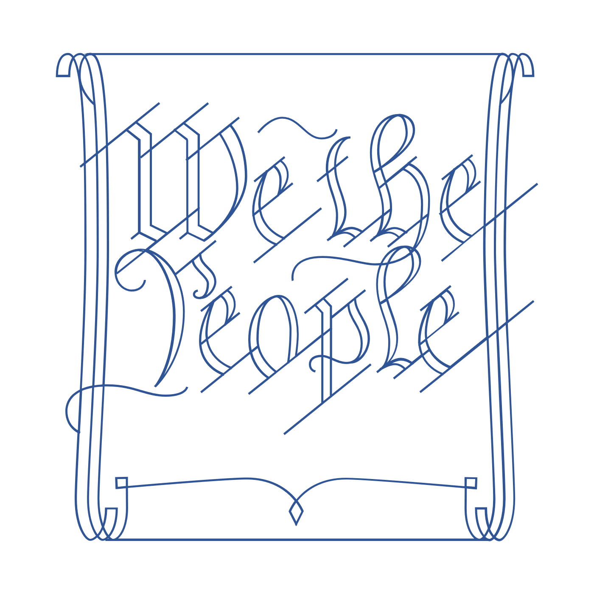
Scholar Exchange: Civil Rights Movement
Advanced Level Class Outline and
Worksheet

INTERACTIVE CONSTITUTION RESOURCES

- Resources for Civil Rights Movement

OVERVIEW

Part I: Civil Rights Organizations and Their Leaders
Part II: Civil Rights and America’s Founding Documents
Part III: The Reconstruction Era to the Rise of Jim Crow
Part IV: Brown v. Board of Education
Part V: The Aftermath of Brown: Nonviolent Direct Action Outside of the Courts
Part VI: Civil Rights Laws in the Era of President Lyndon B. Johnson

QUESTIONS TO CONSIDER

- What was the Civil Rights Movement? When was it active? Who were some of its leaders?
- What were some of the Civil Rights Movement’s core constitutional arguments?
- What did the original Constitution say about civil rights, and how did later amendments transform our nation’s charter?
- What was the Warren Court, and what were some of its key rulings in the 1950s and 1960s?
- What were some of the landmark civil rights laws passed during the Civil Rights Era?
- What is the constitutional legacy of the Civil Rights Movement and the Warren Court?

BIG IDEA

While the American people wrote the Declaration of Independence’s promise of freedom and equality into the Constitution after the Civil War, it would take nearly a century and the courage of many African Americans and their allies in the Civil Rights Movement—coupled with important decisions by the Warren Court and landmark statutes like the Civil Rights Act of 1964 and the Voting Rights Act of 1965—to make these promises a reality.

NOTES:

PART I. CIVIL RIGHTS ORGANIZATIONS AND THEIR LEADERS
Write something you learned about at least two of the following organizations:
The NAACP, Southern Christian Leadership Conference (SCLC), Congress of Racial Equality (CORE), Leadership Conference on Civil Rights (LCCR), Student Nonviolent Coordinating Committee (SNCC), and the Committee for Equal Justice.
Organization Name | Something you learned about it | One person associated with it

PART II: CIVIL RIGHTS AND AMERICA’S FOUNDING DOCUMENTS
Explain how civil rights reformers used at least two of the following documents:
The Declaration of Independence, Prince Hall’s 1777 petition, Speech by Frederick Douglass, Constitution’s Preamble, Reconstruction Amendments, 20th Century Constitution Amendments
Document | How did civil rights reformers use the document?

PART III. THE RECONSTRUCTION ERA TO THE RISE OF JIM CROW
What was one way that the Reconstruction Era was successful?
How did the rise of Jim Crow laws change that?

PART IV. BROWN V. BOARD OF EDUCATION
What was the decision in Brown v. Board of Education?
Who are some people associated with the Brown case?
What was the decision in Plessy v. Ferguson?
How is that case related to Brown?
How did the Brown decision help reinvigorate the 14th Amendment?

PART V: THE AFTERMATH OF BROWN: NONVIOLENT DIRECT ACTION OUTSIDE OF THE COURTS
There are many examples of nonviolent direct action during the Civil Rights Movement:
Montgomery Bus Boycott, a national student-led sit-in movement, Freedom Riders, university integration, Dr. Martin Luther King Jr., and the March on Washington and Dr. King’s “I Have a Dream” Speech.
Pick one of the examples to answer the following questions.
What were the actions taken by the members of the Civil Rights Movement?
What are some examples of opposition to the nonviolent direct action you chose?

PART VI: CIVIL RIGHTS LAWS IN THE ERA OF PRESIDENT LYNDON B. JOHNSON
 | What did the Civil Rights law do? | Name on Supreme Court case associated with it. | Provide detail about any opposition to the law.
Civil Rights Act of 1964
Voting Rights Act of 1965

