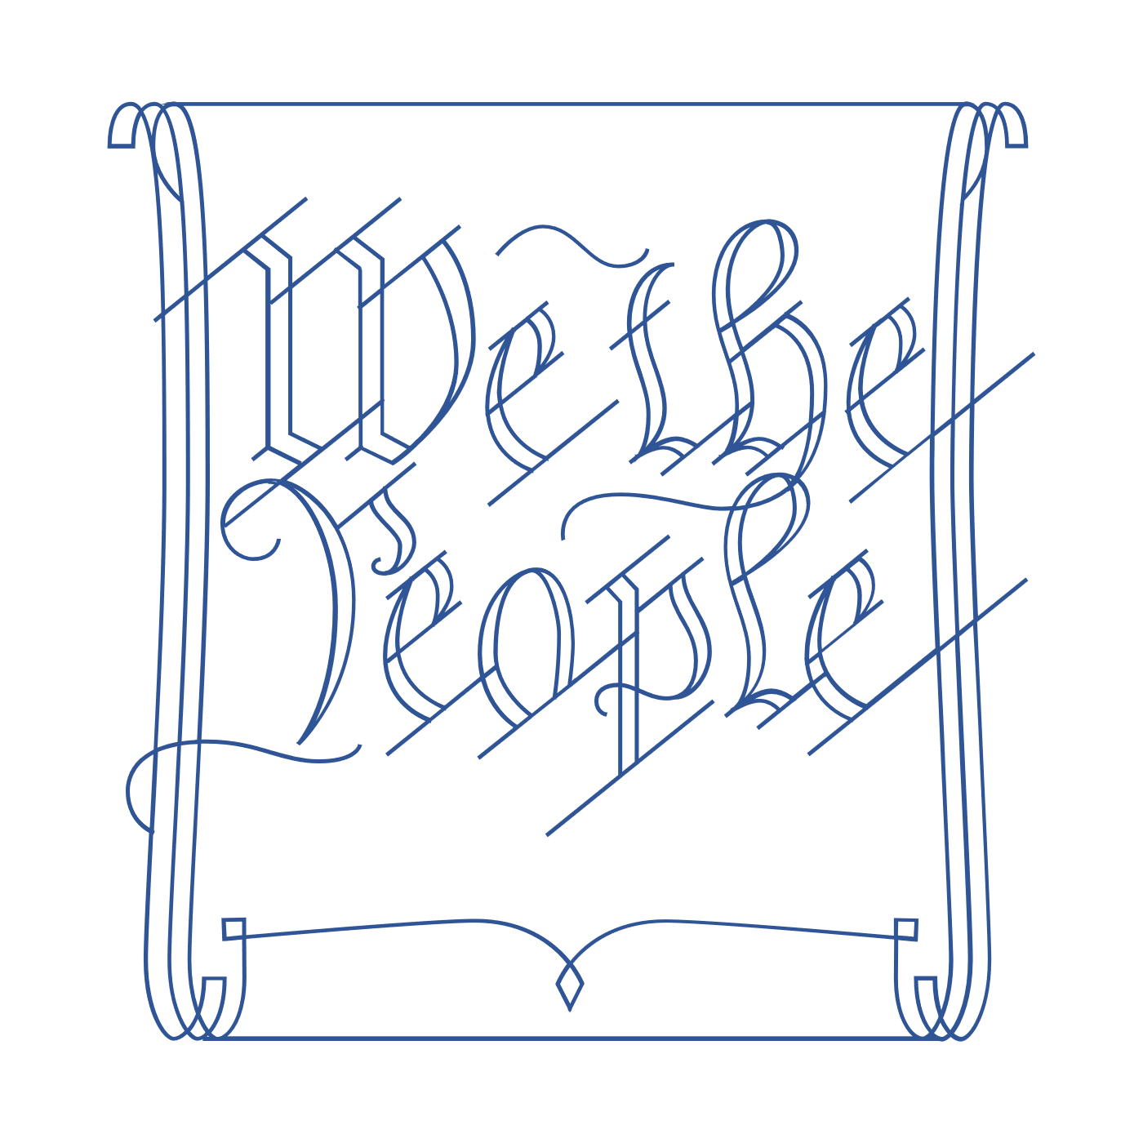
Scholar Exchange: Principles of the American Constitution: 1776-1787
Advanced Level
Class Outline and Worksheet

INTERACTIVE CONSTITUTION RESOURCES

- Resources for Principles of the American Constitution (Articles of Confederation)

OVERVIEW

Warm Up
Part I: ROAD TO THE CONVENTION
Part II: PRINCIPLES OF THE AMERICAN CONSTITUTION

FRAMING QUESTIONS

- Why did the Founding generation decide to write a new Constitution?
- What was the Articles of Confederation, and what sort of national government did it establish?
- What did the Founding generation learn from the state constitutions that the American people wrote before the U.S. Constitution?
- What was Shays’ Rebellion, and how did it influence the Founding generation?
- What key principles underlie the U.S. Constitution, and what sort of system of government did the Founding generation establish?

BIG IDEAS

The Founders were children of the Enlightenment. When crafting a new Constitution, they learned from history and from their own experiences. Between the Declaration of Independence and the U.S. Constitution, the American people were governed at the national level by the Articles of Confederation and at the state level by state constitutions. With the U.S. Constitution, the Founding generation established a new national government. This new government was more powerful than the national government established by the Articles of Confederation, but also one of limited powers.

WARM UP
What are some ways that the U.S. Constitution balances the powers of “the one, the few, and the many”? Provide two or three examples.

PART I: ROAD TO THE CONVENTION
The Articles of Confederation
The Articles created a weak central government, or a “league of friendship”.
Describe the structure of the government under the Articles of Confederation and some of the limits of its powers.
Structure of the government | Limits of its power
Shays’ Rebellion
Massachusetts, 1786

What are three causes of Shays’ Rebellion?
1.

2.

3.

What did the Founding generation learn from Shays’ Rebellion?

PART II: PRINCIPLES OF THE AMERICAN CONSTITUTION
We are going to focus on some of the key principles underlying the U.S. Constitution: popular sovereignty, federalism, separation of powers, checks and balances, and republicanism.

Principle | Definition  (in your own words) | Key Words, Ideas, or People
Popular Sovereignty
Federalism
Separation of Powers
Checks and Balances
Republicanism

Five Key Constitutional Principles
Let’s explore how these key principles combine into a broader vision for the national government under the new Constitution.

How do these principles, working together, create a system of limited powers in the Constitution?

What role did the Federalist Papers play in advocating for these principles?

FINAL REFLECTION
Before we end the session today, let’s reflect back on the question we asked at the beginning:
What are some ways that the U.S. Constitution balances the powers of “the one, the few, and the many”?
Can you add two or three words to your original answer based on what you heard today?

Notes: Take notes here or list all of your questions for the scholar

