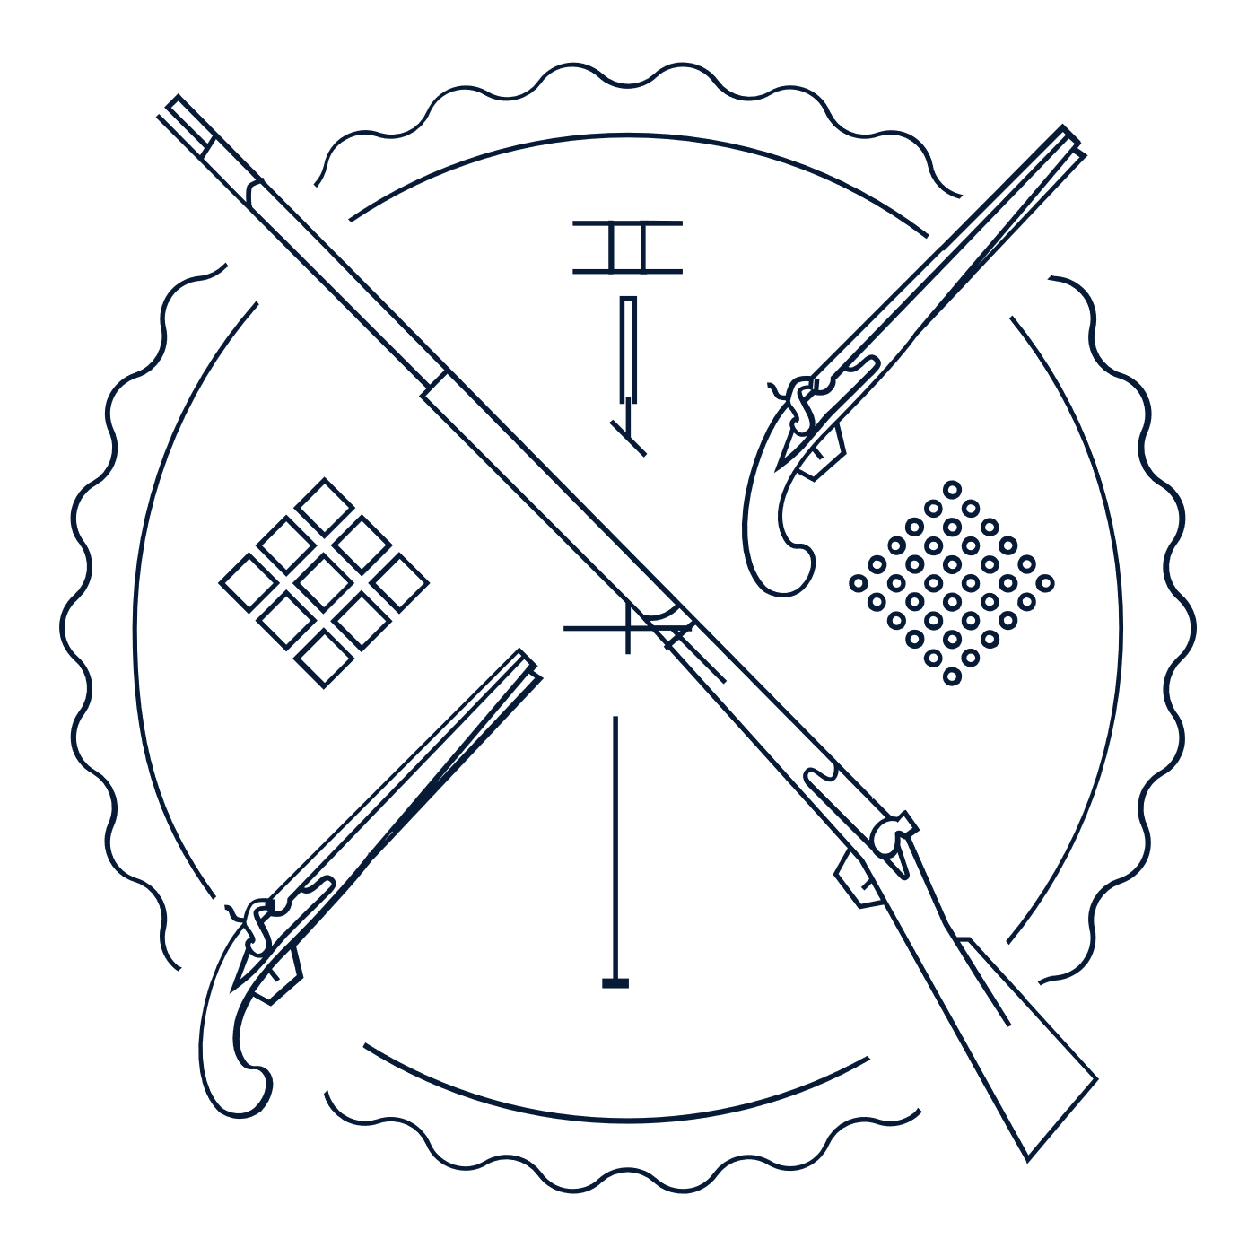
Scholar Exchange: Second Amendment
Briefing Document

INTERACTIVE CONSTITUTION RESOURCES

- Resources for the Second Amendment

INTRODUCTION

Big Questions

- Why did the Founding generation enshrine the Second Amendment in the Bill of Rights?
- What was the Founding-era vision of the Second Amendment, and how did America’s “Second Founding”—and the ratification of the Fourteenth Amendment after the Civil War—shape the Second Amendment’s meaning?
- How has the Supreme Court interpreted the Second Amendment over time?
- Today, when can the government limit the individual right to possess guns and other firearms—and when can’t it?
- What are areas of constitutional debate over the Second Amendment today?

Text of the 2nd Amendment:

A well regulated Militia, being necessary to the security of a free State, the right of the people to keep and bear Arms, shall not be infringed.

INTRODUCTION TO THE CONSTITUTION’S TEXT

Let’s begin—as we always do when interpreting the Constitution—with the Constitution’s text. Looking at the Second Amendment’s text, it’s worth noting that the Amendment can be separated out into two clauses:

There’s the first part (which lawyers usually call the “prefatory clause”). This part of the Amendment goes to the Second Amendment’s connection to the Founding generation’s commitment to the citizen-soldier, organized around local militias. This language expresses at least one of the Amendment’s core purposes—preserving “the security of a free State” through a “well regulated Militia,” comprised of members of the local community.

Many Founders feared a national army filled with professional soldiers. They thought that history taught us that these sorts of armies might lead to tyranny. Instead, the Founders thought it better to protect ourselves through local militias formed through groups led by our community’s leaders and formed by members of the local community. The Second Amendment would protect our ability to arm ourselves so that we can carry out our local militia duties without fear of the national government disarming us. So, this language is about federalism—protecting the powers of state (and local) governments and limiting the powers of the national government.

The second part of the Amendment then goes to the substance of the right itself. (Lawyers call it the Amendment’s “operative clause.”). This text expresses a core “right of the people”—the right “to keep and bear Arms.” And at the Founding—like the rest of the Bill of Rights—this text protected against the national government “infring[ing]” that right. (It didn’t apply to state governments.)

This quick review of the Amendment’s text helps us understand one of the arguments at the core of the constitutional debates over the Second Amendment’s meaning:

Does the Second Amendment protect a right to keep and bear arms only when reasonably connected with militia service? If so, this would greatly limit the Amendment’s reach, since we are no longer committed to local militias in the way that the Founding generation envisioned.

Or does the Second Amendment also protect a freestanding right to keep and bear arms—one not necessarily connected to militia service? On this view, the Amendment’s prefatory clause sets out an important reason for protecting gun rights, but not the only reason. In turn, the Amendment’s second part speaks in broad language about the right to keep and bear arms and protects an individual right separate from whether or not one serves in the local militia.

The Supreme Court addressed this debate in its landmark case, District of Columbia v. Heller, which we’ll discuss shortly. As we will see, this was the first modern Supreme Court case about the scope of the Second Amendment. But first, this week’s big question—which we should keep in mind throughout today’s session.

Big Question: When can the government limit the individual right to possess guns and other firearms—and when can’t it? To begin to answer these questions, we must first consider not one—but two—Founding stories. One brings us back to the Founding generation. And the other one transports us to the Civil War, Reconstruction, and our nation’s Second Founding.

FOUNDING STORIES FROM AMERICA’S FOUNDING ERA

The Founding-era story brings us back to the American Revolution, the Original Constitution, and the Bill of Rights. This story offers us two big lessons. First, many members of the Founding generation were suspicious of standing armies—professional armies, paid by the government and separate from local citizen militias. And second, many members of the Founding generation greatly valued citizen militias—organized by state and local governments, led by local community leaders, and comprised of members of the local community.

The Founding-era story that’s important to the foundation of the Second Amendment begins with the presence of the British army in colonial America. At this time, the British army was seen as an imperial occupying force, especially in Boston where the colonial government was suspended.

For instance, consider the Quartering Acts. Boston had a population of around 15-16,000 people, and, by 1775, the British stationed 4,000 soldiers there. (This was more than the population of military-age males in Boston.). For the colonists, the British troops truly felt like an overwhelming force present everywhere, including (thanks to the Quartering Acts) inside the home. So, this experience colored the meaning of “standing armies” for early Americans.

And these concerns not only helped to shape the Second Amendment, but they also helped give rise to the Third Amendment as well.

These events led to a growing and widespread suspicion of standing armies. For instance, the Declaration of Independence charged that King George III had “kept among us, in times of Peace, Standing Armies without the Consent of our legislatures” and had “affected to render the Military independent of and superior to the Civil power.” This concern also went back to the English Bill of Rights, which said that, the “raising or keeping a standing army within the kingdom in time of peace, unless it be with consent of Parliament, is against law.”

The argument: Professional armies—like the British Army and the Hessians—couldn’t be trusted. European monarchies and despots had standing armies. In America, we needed virtuous citizen-soldiers like the militia. The Founding generation here looked to the example of the Greek city-states and the Roman army during the Republic. Part of the breakdown of the Roman Empire was its reliance on conscripts and hired soldiers over citizen-soldiers, degrading its republican character.

Founding Vision: The Second Amendment grew out of the popular belief in Founding-era America that standing armies posed a danger to liberty, and that the better way to defend the nation while preserving freedom was the militia, composed of all able-bodied men of fighting age in the community.

Many also believed that the right to self-defense and to individual arms was a pre-constitutional right that was among the natural rights of all persons. Those thinking of the right to self-defense could point to the English Bill of Rights of 1689 (“subjects which are Protestants may have arms for their defence suitable to their conditions and as allowed by law”). This understanding of the right was cited by Justice Scalia in District of Columbia v. Heller. The core idea is that militia duty is a key part of republican citizenship. Citizens fulfill this duty, and the government steers clear of a standing army.

These early concerns are reflected in state constitutions in place during the Founding era.

Some states specified individual rights to bear arms in their state constitutions, while others did not and only had language about the militia.

At the same time, all of the state constitutions during this period mentioned militia duty, opposition to standing armies, and a division of authority between the army/military and the civilian government—with military power controlled by a non-military/civilian government.

What lessons did the Founders draw from history and the American Revolution? They feared a standing army. But they also feared relying on a poorly trained militia to defend the nation.

So, with the new Constitution, they looked to give the national government new powers over the military in the interests of national security. The U.S. Constitution itself contained provisions known as the “Militia Clauses” setting out the relationship between Congress, the militia, and the states. (So, these Clauses come before the Bill of Rights—and the Second Amendment.)

Article I, Section 8, gives Congress the power to “provide for calling forth the Militia to execute the Laws of the Union, suppress Insurrections and repel Invasions.”

And here’s a bit more from Article I, Section 8. It gives Congress the power to “provide for organizing, arming, and disciplining, the Militia, and for governing such Part of them as may be employed in the Service of the United States, reserving to the States respectively, the Appointment of the Officers, and the Authority of training the Militia according to the discipline prescribed by Congress.”

And Congress was also given the separate power to “raise and support Armies” (with money for that purpose limited to no more than two years) and to “provide and maintain a Navy.”

At the same time, the Original Constitution did not contain an analogue to the state “anti-standing armies” provisions.

Federalists like Alexander Hamilton felt that a limitation on Congress’s power to “raise and support armies” would needlessly impair the ability to the national government to protect the people.

Key Point: With the new Constitution, the national government is given broad authority to establish a peacetime standing army and to regulate the militia.

In the debates over the Original Constitution, the Federalists (supporting the new Constitution) and the Anti-Federalists (opposing it) battled over the threat of standing armies and the scope of the national government’s power over national security and citizen militias.

First, consider the Constitutional Convention itself. At the end of the Convention, three delegates refused to sign the final draft of the Constitution. These dissenters were Edmund Randolph, Elbridge Gerry, and George Mason.

Earlier in the proceedings—roughly a month earlier, on August 18—both Randolph and Mason (along with James Madison) supported a provision that guarded against “standing armies in times of peace.” Other delegates like G. Morris argued against it. And only Virginia and Georgia voted for it.

In the end, those who refused to sign the Constitution—for instance, Gerry, and especially Mason—highlighted the fact that the Constitution didn’t provide any protections against standing armies.

Big Point: The Constitution’s massive shift of power from the states to the national government in this context was a major objection to the new Constitution for the emerging Anti-Federalists.

Turning to the ratifying debates, both key Federalists and key Anti-Federalists battled over the proposed Constitution, standing armies, and the scope of national power. To give a sense of the stakes—and why this debate mattered to the Founding generation—let’s review the key arguments on each side. These arguments would shape the Second Amendment.

First, let’s review some of the Federalist arguments. In The Federalist Papers, both Hamilton and Madison addressed the issue of standing armies and the militia. The central idea behind Alexander Hamilton’s arguments was that the Constitution was necessary for national security reasons and thus standing armies were sometimes needed to secure the liberties of the people.

For Hamilton, the American Revolution showed that we shouldn’t rely on state-organized militia for national defense. At the same time, James Madison tried to chart a middle course between Hamilton and the Anti-Federalists. Madison agreed that standing armies were an essential part of modern states and necessary to security. However, he added that what afforded Americans protection against foreign threats was not only a standing army, but the militia as well. Both were necessary to protect a free republic.

Madison’s Main Point: The Anti-Federalist concerns about a national army overpowering the American people are probably overblown. The American people are almost impossible to subdue. American militias were big, and the American people were armed.

Good luck, standing army!

At the same time, Anti-Federalist “Brutus”—thought to be New York’s Robert Yates—wrote many times about the anti-republican character of standing armies. For Brutus, the power of Congress to raise and support armies at its pleasure in times of peace and war and to control the militia evinced a tendency toward consolidation of government and “destruction of liberty.”

Like the Dissenters at the Convention, Brutus and his Anti-Federalist allies feared the dangers of a standing army under the new Constitution. With the Second Amendment, the Founders responded to some of the Anti-Federalists’ concerns—advancing a republican conception of gun rights, militia service, and a right to bear arms.

The Second Amendment responds to the Anti-Federalist fears that Congress might use its power to “organize, arm, and discipline” the militia as an excuse to disarm the American people. The Second Amendment prevents this.

Key Points: The U.S. Constitution gives the national government broad authority over the army and the militia.

So, the Federalists didn’t make any real concessions to the Anti-Federalists on standing armies and the military powers of the national government. But they do write certain key protections into the Second Amendment.

In the end, the Militia Clauses and the Second Amendment are paradigmatically about promoting public safety and promoting the common good.

FOUNDING STORIES FROM THE CIVIL WAR AND RECONSTRUCTION ERA

Our second set of stories brings us to the Civil War, Reconstruction, and (what many scholars refer to as) our nation’s “Second Founding.”

Framing Question: How did the Civil War, Reconstruction, and the Second Founding transform debates over the Second Amendment and the right to keep and bear arms? And specifically, why were gun rights so important to African Americans in the South following the Civil War?

Civil War and Reconstruction Era

After the Civil War, white Southerners passed new laws—the Black Codes—which discriminated against African Americans and tried to impose the conditions of slavery on them again. As part of this move, these Black Codes tried to take away their arms.

In response to the Black Codes, Frederick Douglass argued that we needed national action to protect African American rights:

“The black man has never had the right either to keep or bear arms; and the legislatures of the states will still have the power to forbid it.”

For Douglass, the national government had to step in to protect this key right.

And here are the words of a convention of African Americans in South Carolina:

“We, the people of the State of South Carolina, in Convention assembled, . . . ask that, inasmuch as the Constitution of the United States explicitly declares that the right to keep and bear arms shall not be infringed . . . that the late efforts of the Legislature of this state to pass an act to deprive us of arms be forbidden, as a plain violation of the Constitution.”

At the same time, the national army (victorious in the Civil War) becomes a symbol for many Americans—not of tyranny or repression—but of liberty.

And private militias—associated with groups like the Ku Klux Klan, which were formed after the Civil War—become a symbol of violence against African Americans. Of course, this turns the Founding-era debate over standing armies on its head. White violence against African Americans led them to embrace gun rights as a means of protecting themselves, their homes, their families, their friends, and their neighbors. It’s no wonder that the Reconstruction Congress was especially concerned that the right to keep and bear arms be protected in order to enable African Americans to protect themselves from violence.

The Reconstruction Congress built new protections for African American gun rights into landmark laws like the Civil Rights Act of 1866.

Senator Lyman Trumbull specifically targeted a Mississippi law banning African Americans “from having fire-arms.”

Or look at the Freedman’s Bureau Act, which affirmed that “laws . . . concerning personal liberty [and] personal security . . . including the constitutional right to bear arms, shall be secured to and enjoyed by all citizens.”

Senator Samuel Pomeroy: “If the cabin door of the freedman is broken open and the intruder enters for purposes as vile as were known to slavery, then should a well-leaded musket be in the hand of the occupant. . . . Every man . . . should have the right to bear arms for the defense of himself and his family and his homestead.”

And when drafting and debating the Fourteenth Amendment, many Reconstruction leaders expressed concerns about protecting the rights of African Americans to keep and bear arms in order to defend themselves from Southern white violence.

In the end, the Fourteenth Amendment and these landmark laws cemented the creation of a new constitutional vision of the Second Amendment as protecting an individual right to keep and bear arms.

In 1892, Ida B. Wells captured the importance of this shift to the African American community:

“[A] Winchester rifle should have a place of honor in every black home. . . . When the white man . . . knows he runs as great a risk of biting the dust every time his Afr[ican]-American victim does, he will have a greater respect for Afr[ican]-American life.”

The Fourteenth Amendment was ratified in 1868.

In the ensuing decades, the Supreme Court would decide cases that limited its reach—including in the context of gun rights.

For instance, take United States v. Cruikshank (1876). This case arose out of one of the largest—if not the largest—incidents of white violence against African Americans during Reconstruction, the Colfax Massacre in April 1873. The incident takes place in Louisiana.

There’s confusion after the election of 1872. Both parties claimed victory. Two Governors and two state legislatures claiming legitimacy. The two sides tried to take control of the Colfax Courthouse. The Republicans (including the local African American militia) succeeded in occupying it—reinforced by armed supporters. The militia began arming and drilling—with many African Americans armed with the rifles they had carried as Union soldiers.

This infuriated local whites.

On April 13, 1873, a white mob—led by the Ku Klux Klan—stormed the courthouse. All told, a group of 150 white people attacked the courthouse and eventually drove African Americans out of the building by setting fire to it. More than 100 African Americans were shot and killed as they fled the fire. William Cruikshank and others were prosecuted for these murders under the Enforcement Act of 1870.

They were charged with infringing many constitutional rights, including Second Amendment rights, and some of them were convicted.

The Court unanimously rules that the suit was improper—throwing out the indictments against the alleged murderers.

Chief Justice Waite says that the national government does not have power to protect against Bill of Rights violations by private—as opposed to government—actors.

After all, the Fourteenth Amendment says “No state shall . . .” not “No one shall . . .” (Lawyers call this the “state action” requirement.)

Chief Justice Waite on the Second Amendment/BOR Issue:
The right to bear arms is not a right granted by the Constitution nor does it depend on the constitution for its existence and the Second Amendment only restricts the powers of the national government.

MODERN SECOND AMENDMENT CASES

Hypothetical question: Can a city effectively ban handguns within city limits? (District of Columbia v. Heller (2008) and McDonald v. City of Chicago (2010))

We’ve spent a lot of time on the Second Amendment’s history. But how does the Supreme Court apply the Second Amendment today?

One odd feature of this area of the law is that while the Second Amendment itself (and even the Fourteenth Amendment) are old, the Supreme Court hasn’t discussed the Second Amendment’s meaning all that much throughout its history.

District of Columbia v. Heller (2008)

In Heller, the challengers argued that a District of Columbia law effectively banning handguns violated the Second Amendment. This case featured powerful originalist opinions—tackling the Second Amendment’s text and the Founding-era history—on both sides.

And the decision turned, in part, on the outcome of the debate over whether the Second Amendment protected a collective right (tied to militia service) or an individual right to keep and bear arms (that applied more generally). If the collective rights side won, it would mean that governments had a great deal of discretion to regulate guns. If the individual rights side won, it would mean that the Second Amendment might place limits on a range of gun regulations that limit the rights of individuals.

The Supreme Court—in a 5-4 decision—endorsed the individual rights view. For the majority, the Second Amendment grants an individual right to keep and bear arms—including personal handguns in the home—subject to reasonable regulation outside of the home.

Justice Antonin Scalia authored the majority opinion. Scalia argued that it’s clear from the Founding-era history that words like “arms” and “bear” referred to individual rights to own commonly held (so, widely owned and used) firearms. This could mean offensive or defensive weapons—and not just arms of war. He says that the militia at the Founding referred to a subset of the American people—male, able-bodied, and of a certain age. So, with the Second Amendment, the Founding generation didn’t use the words “the people” to refer to the collective rights of the people broadly, but instead to a right held by individuals. And the phrase “keep arms” refers to “hav[ing] weapons” outside of an organized militia.

Scalia addressed the Second Amendment’s prefatory clause and operative clause. The “militia” clause is the prefatory clause, and the “right to bear arms” the operative. Scalia says that a prefatory clause does not limit or expand the operative clause. Instead, it lays out a relevant reason—but not necessarily the only reason—behind the substantive right protected in the operative clause. For Scalia (and the majority), the Amendment could be rephrased, “Because a well regulated Militia is necessary to the security of a free State, the right of the people to keep and bear Arms shall not be infringed.”

Scalia argued that the Second Amendment codified a pre-existing right—like the First and Fourth Amendments—going back to English common law. The core of this right is an individual right to possess and carry weapons in case of confrontation. 1689 English Bill of Rights: “That the subjects which are Protestants may have arms for their defense suitable to their conditions and as allowed by law.”

Finally, he looks to state constitutions. He says that these documents show that before the Second Amendment, the right to bear arms for defensive purposes was secure. Anti-Federalists wanted such an amendment because of the threat that the new Federal Government would destroy the citizens’ militia by taking away their arms.

In dissent, Justice John Paul Stevens offered a different way of reading the Second Amendment’s text and the Founding-era history. He concluded that the D.C. law was constitutional. Justice Stevens reviewed the Founding-era history, including the provisions in state constitutions and the amendments offered by ratifying conventions—so, materials we reviewed earlier. Stevens thought it was crucial that—when drafting the Second Amendment—James Madison rejected versions of the Amendment that clearly protected an individual right to keep and bear arms. Instead, Stevens observed, Madison drew on proposals from Virginia.

Stevens: The “distinctly military Virginia proposal is therefore revealing, since it is clear that he considered and rejected formulations that would have unambiguously protected civilian uses of firearms.” (For instance, Thomas Jefferson wrote a proposed amendment that would have included within the Virginia Declaration the following language: “No freeman shall ever be debarred the use of arms [within his own lands or tenements].”)

In light of this history, Stevens argued that the Second Amendment was primarily about standing armies and the militia right—not an individual right to keep and bear arms separate from militia service. Stevens argued that the Founding generation was most interested in the proper allocation of military power between the state governments and the national government.

McDonald v. City of Chicago (2010)

The second landmark case—McDonald v. City of Chicago—answered the natural follow-up question.

The original Bill of Rights only applied to abuses by the national government. Heller addressed a District of Columbia gun law. Since D.C. is not a state and is governed by federal law, the Supreme Court in Heller was simply asked to apply the Second Amendment directly. By challenging a similar handgun ban in Chicago, the McDonald case asked the key follow-up question: Does the Fourteenth Amendment extend the Second Amendment’s key protections to state abuses? This question goes to the issue of (what lawyers call) “incorporation.”

In a divided 5-4 decision, the Supreme Court concluded that the Fourteenth Amendment did extend the Second Amendment’s key protections to state abuses—and struck down the Chicago handgun ban. The Court held that the right to keep and bear arms for the purpose of self-defense was “deeply rooted” in the nation’s history. And the Second Amendment was thus incorporated against the states through the Fourteenth Amendment—meaning that the states could not infringe on that right.

These two cases—Heller and McDonald—begin to establish a legal framework for applying the Second Amendment in new cases. These cases establish a core principle—The Second Amendment protects an individual right to gun possession for purposes of protecting one’s home. And they begin to set the boundaries of the Second Amendment’s protections—beginning by striking down some of the strictest gun laws in the country (handgun bans in DC and Chicago). However, these cases also emphasize that the Second Amendment right isn’t absolute. (Scalia’s language in Heller).

Importantly, Justice Scalia’s Heller opinion acknowledged “longstanding prohibitions on the possession of firearms by felons and the mentally ill, or laws forbidding the carrying of firearms in sensitive places such as schools and government buildings, or laws imposing conditions and qualifications on the commercial sale of arms.” It also limits Second Amendment rights to weapons in common use. So, the Heller Court affirmed the “historical tradition of prohibiting the carrying of ‘dangerous and unusual weapons.’” In other words, the Second Amendment might protect ordinary handguns, but not bazookas.

Even so, many questions remain. For instance, some Justices (like Justice Thomas) argue that we’re treating the Second Amendment as a second-class right (or a “disfavored right” which makes it seem “antiquated and superfluous”). They think that we should read the Second Amendment much as we do the First Amendment—providing strong protections. But even under Heller, the Court accepts that the right isn’t absolute and that some regulations should stand. And critics of Thomas’s approach argue that the proper analogy is to First Amendment “time, place, and manner” restrictions. Importantly, the Supreme Court just accepted review of New York’s “carry and concealed” law, which will be argued next Term. This case asks the questions of whether Heller protects an individual’s right to “bear arms” outside of the home.

*Research provided by Nicholas Mosvick, senior fellow for constitutional content, and Thomas Donnelly, senior fellow for constitutional studies, at the National Constitution Center.

