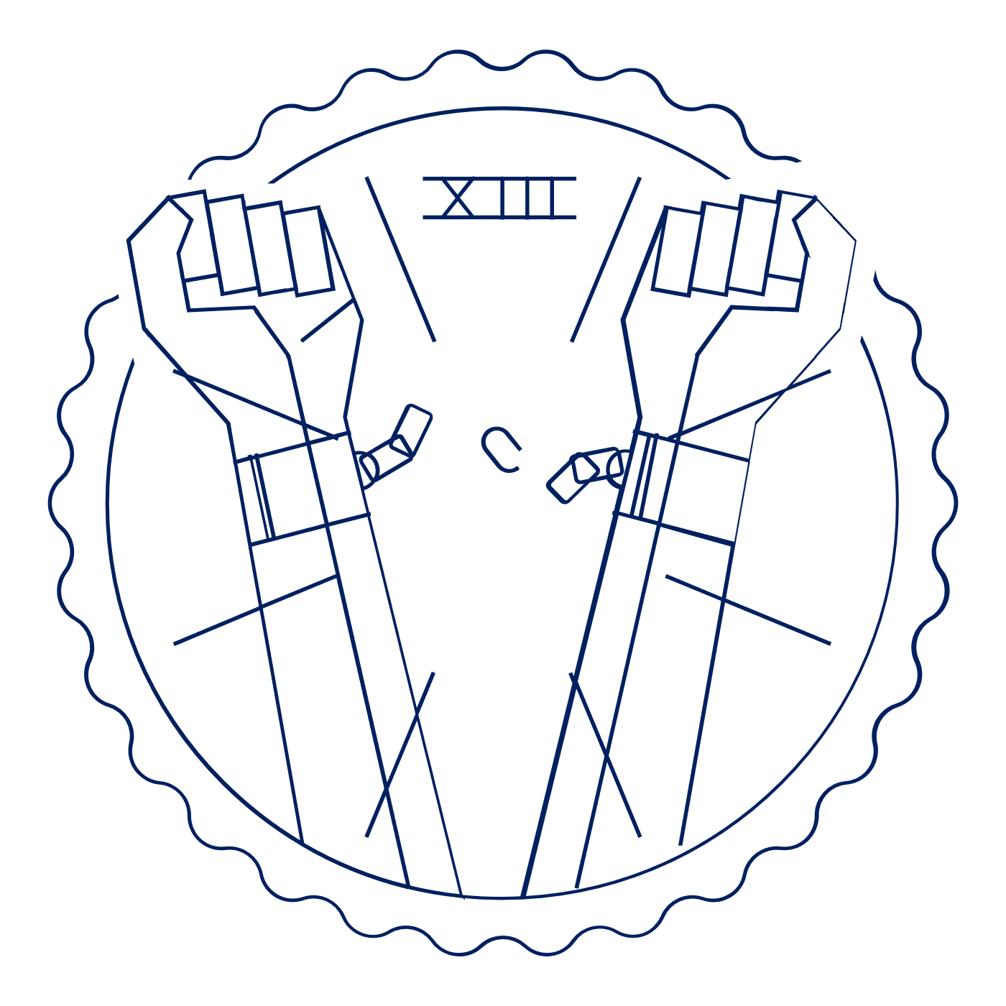
Scholar Exchange: Slavery in America
Advanced Level
Class Outline and Worksheet

INTERACTIVE CONSTITUTION RESOURCES

- Resources for Slavery in America

OVERVIEW

I. Introduction
II. The Founding Generation and the Early Republic
III. Pre-Civil War America
IV. The Civil War and Reconstruction

QUESTIONS TO CONSIDER

- Slavery was embedded into America’s fabric by the time of the ratification of the Constitution. Did this affect how long slavery lasted in America and how it ended?
- The 13th, 14th, and 15th Amendments ended slavery in America and tried to rebuild our nation on a stronger constitutional foundation. Did these amendments change the Constitution so much that it was like a re-birth—a “Second Founding”—of our nation?

BIG IDEA

Generations of Americans battled over slavery and the Constitution—with each side laying claim to the
Constitution’s text and history. These battles culminated in some of the biggest constitutional debates in American history (over the Constitution’s meaning and its relation to slavery), important national compromises (like the Missouri Compromise), infamous Supreme Court decisions (like Dred Scott), pivotal historical events (like the rise of the Republican Party and the election of Abraham Lincoln), the bloodiest war in American history (the Civil War), powerful attacks on slavery (like Lincoln’s Emancipation Proclamation), a decisive Union victory, and a series of transformational amendments to the U.S. Constitution—the 13th, 14th, and 15th—that brought the Constitution more in line with the Declaration of Independence’s promise of freedom and equality.

NOTES:

The Founding Generation and Early Republic
Describe the practice of slavery in America before the Constitution.

Slavery in the Constititution
Briefly describe the three clauses relating to slavery in the U.S. Constitution
Three-fifth Clause

Fugitive Slave Clause
Slave Trade Clause

Pre-Civil War America
Who is one abolitionist you heard about during this session? Give a brief description about who they are and what they did.

Who were Dred and Harriet Scott?
Why did they believe their freedom should be recognized?
What did the Supreme Court decide in Scott v. Sandford?
What did the dissenting opinion in the case say?

The Civil War and Reconstruction
What event triggered the southern states to succeed from the union, beginning the Civil War?
What was the major reason for the South’s secession?
What powers did President Lincoln use to issue the Emancipation Proclamation?
Name one effect of the Emancipation Proclamation.

Describe each Reconstruction Amendment
13th Amendment

14th Amendment

15th Amendment

Why is the Reconstruction time period referred to as the “Second Founding”?

