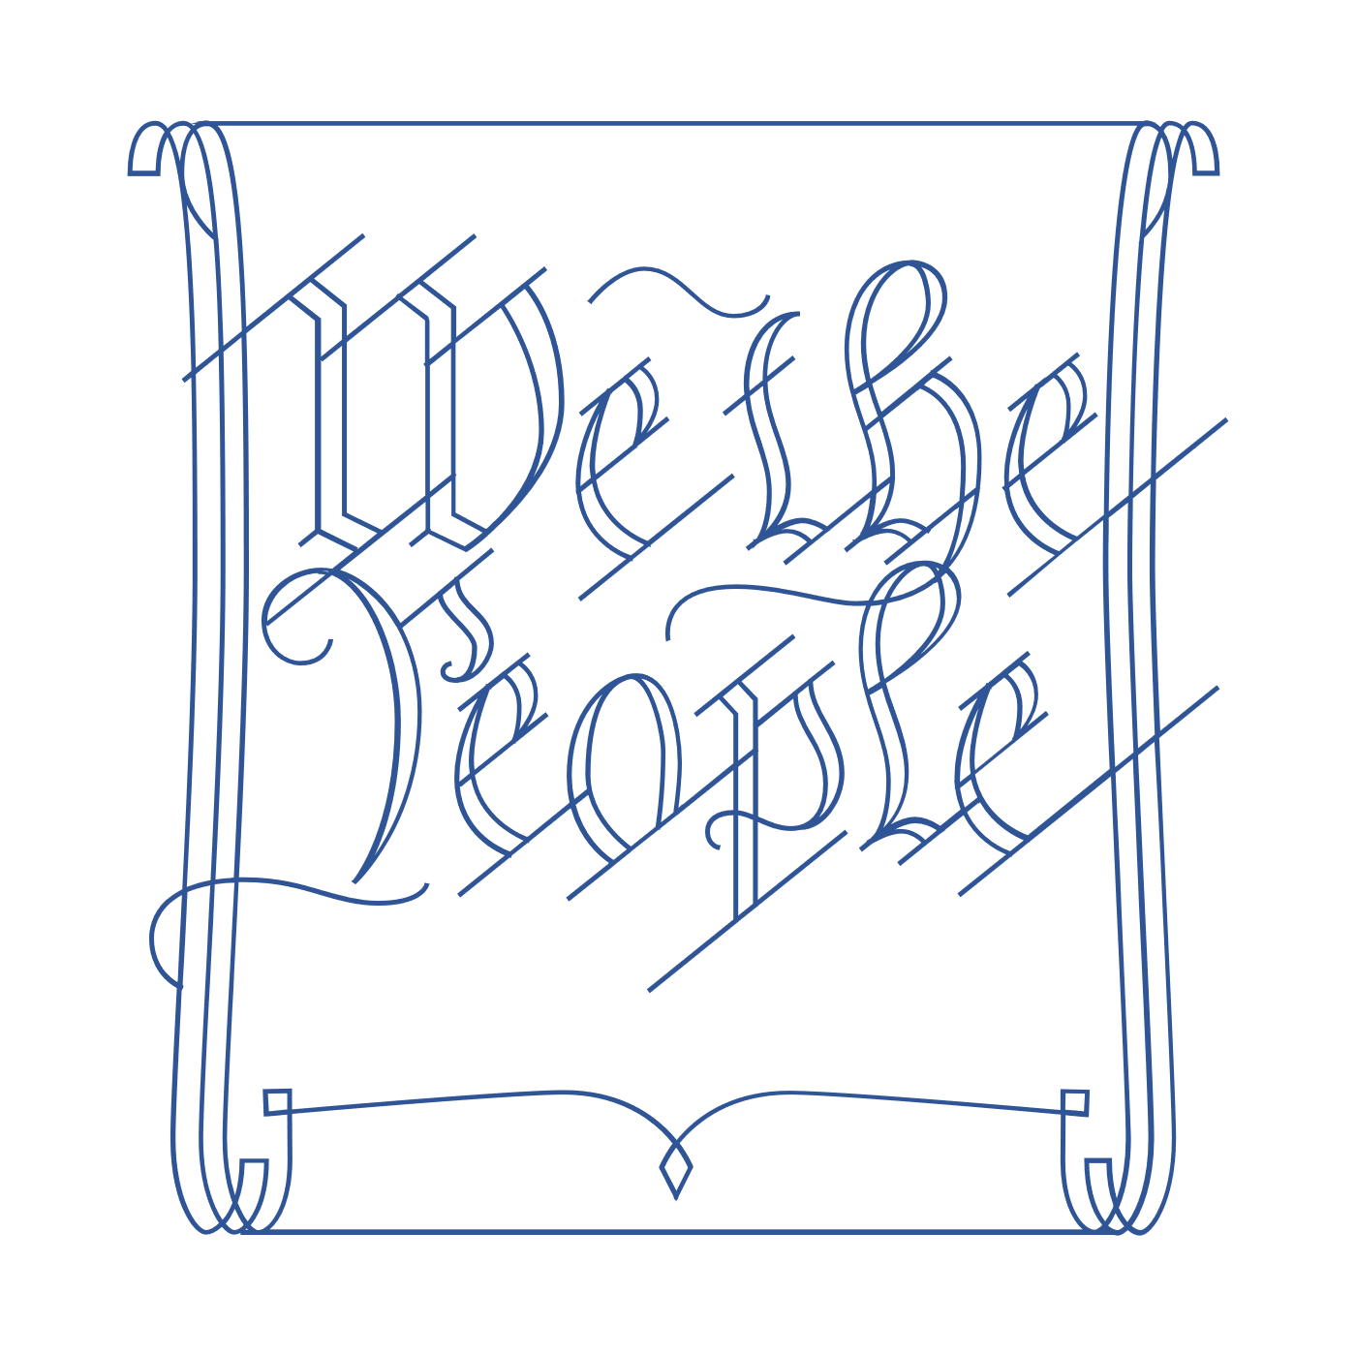
Scholar Exchange: Ratification and The Federalist Papers
Advanced Level
Class Outline and Worksheet

INTERACTIVE CONSTITUTION RESOURCES

- Resources for Article VII

OVERVIEW

Part I: Introduction: The Ratification Fight and Key Players--Federalists and Anti-Federalists
Part II: The Ratification Story--Beginning with the Dissenters at the Constitutional Convention
Part III: The Ratification Fight State-by-State
Part IV: The Anti-Federalists
Part V: The Federalists

QUESTIONS TO CONSIDER
- When was the Constitution completed and signed, and what was the process for deciding whether to adopt it?
- What is ratification?
- Who were the Federalists, and what were some of the key arguments in favor of the new Constitution?
- Who were the Anti-Federalists, and what were some of the key arguments against the new Constitution?
- What were The Federalist Papers, who wrote them, and what did they say?
- How did the ratification process play out at the state level, and how did the supporters of the new Constitution win the battle?
- What role did compromise play in the ratification of the U.S. Constitution?
- What is the relationship between the ratification process and key constitutional principles like popular sovereignty and federalism?
BIG IDEA

When the Constitution was signed by the Framers at the Constitutional Convention on September 17, 1787, it was a mere proposal. The Framers understood that the people themselves still had to accept this new Constitution. Acting through their state ratifying conventions, the American people had to decide whether to give the Constitution life—whether to say “yes” or “no.”

PART I. INTRODUCTION: THE RATIFICATION FIGHT AND KEY PLAYERS
What is “Ratification”?
What was the term for people who supported the Constitution? What were some common traits among the Constitution’s supporters?
Name one famous supporter of ratification.
In your own words, sum up the perspective of the Constitution’s supporters.
What was the term for people who were opposed to ratifying the Constitution?
Name one famous person who opposed ratification.
In your own words, sum up the perspective of those opposed to ratifying the Constitution.

PART II. THE RATIFICATION STORY--BEGINNING WITH THE DISSENTERS AT THE CONSTITUTIONAL CONVENTION
Who knew about the signing of the Constitution on September 17, 1787?
The Dissenters: Who were the three Dissenters at the Constitutional Convention, and why did they object to the Constitution at the time it was signed?
BONUS QUESTION: What made the Constitutional Convention particularly smelly?
NOTES:

PART III. THE RATIFICATION FIGHT STATE-BY-STATE
Why did the smaller states ratify the Constitution quickly?
In your own words, sum up the Massachusetts Compromise. What influence did the Massachusetts Compromise have over the ratification conventions in other states?
What is significant about these dates?
September 17,1787
June 21, 1788

December 15, 1791

PART IV. THE ANTI-FEDERALISTS
Who was Brutus?
Describe one of Brutus’s arguments against the Constitution.

PART V: THE FEDERALISTS
What were The Federalist Papers, and who wrote them?

In your own words, outline the key points to two of the major Federalist Papers written by James Madison
Number | Title | Main Idea

NOTES:

