THE 27 AMENDMENTS TO THE
UNITED STATES CONSTITUTION

Throughout American history, “We the People” have amended our Constitution 27 times—transforming it in important ways. Through the Article V amendment process, we often make it a “more perfect” document. In this activity, you will learn more about key periods of constitutional change and explore the 27 amendments to the Constitution.
___________

The Founding era amendments: 1791 – 1804
Gave us our first 12 amendments, including the Bill of Rights!

Amendment | Read the amendment  on the Interactive Constitution. | Summarize the amendment in your own words. | What are three to five key words or terms associated with this amendment? | What were some factors that led to this amendment being added to the Constitution?
First Amendment  1791 | Text of the Amendment  Common Interpretations:  - Establishment Clause  - Free Exercise Clause  - Free Speech and Press  - Assembly and Petition
Second Amendment  1791 | Text of the Amendment  Common Interpretation
Third Amendment  1791  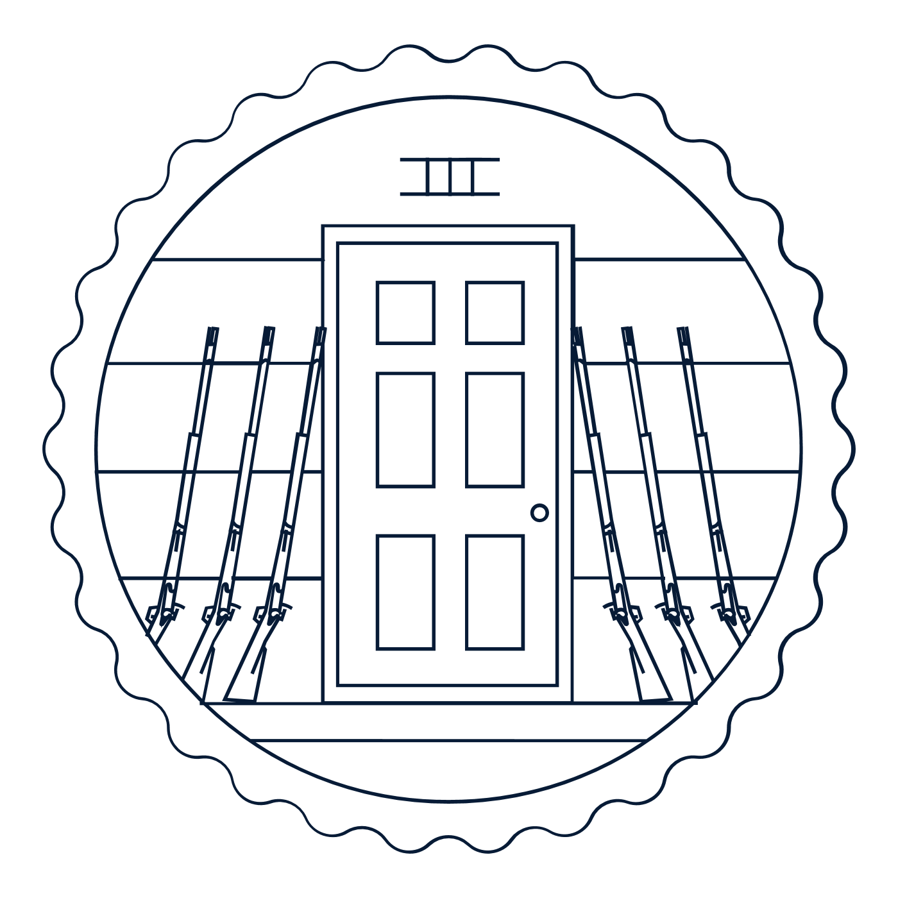 | Text of the Amendment  Common Interpretation
Fourth Amendment  1791  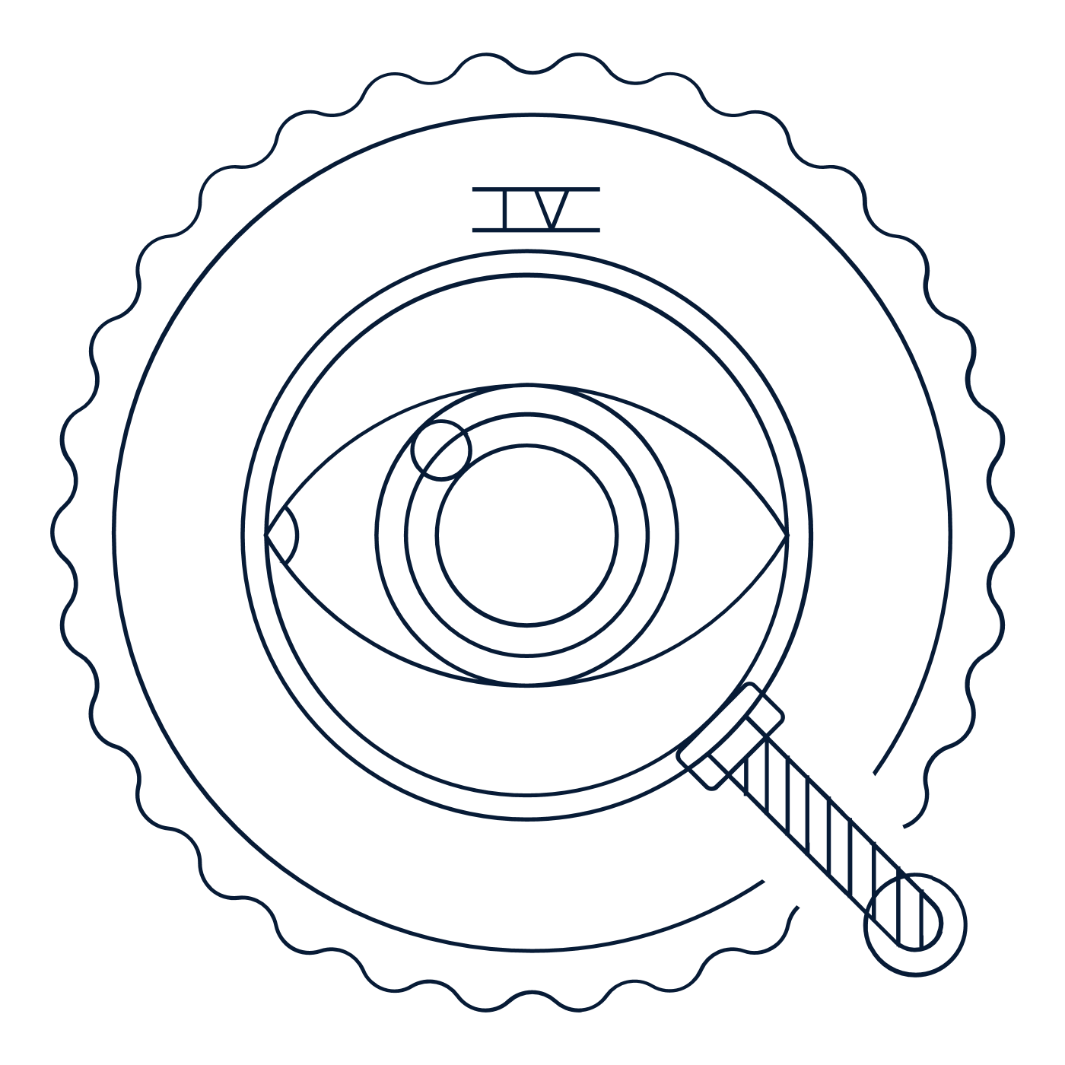 | Text of the Amendment  Common Interpretation
Fifth Amendment  1791 | Text of the Amendment  Common Interpretations:  - Criminal Procedure Clauses  - Due Process Clause  - Takings Clause
Sixth Amendment  1791 | Text of the Amendment  Common Interpretation
Seventh Amendment  1791  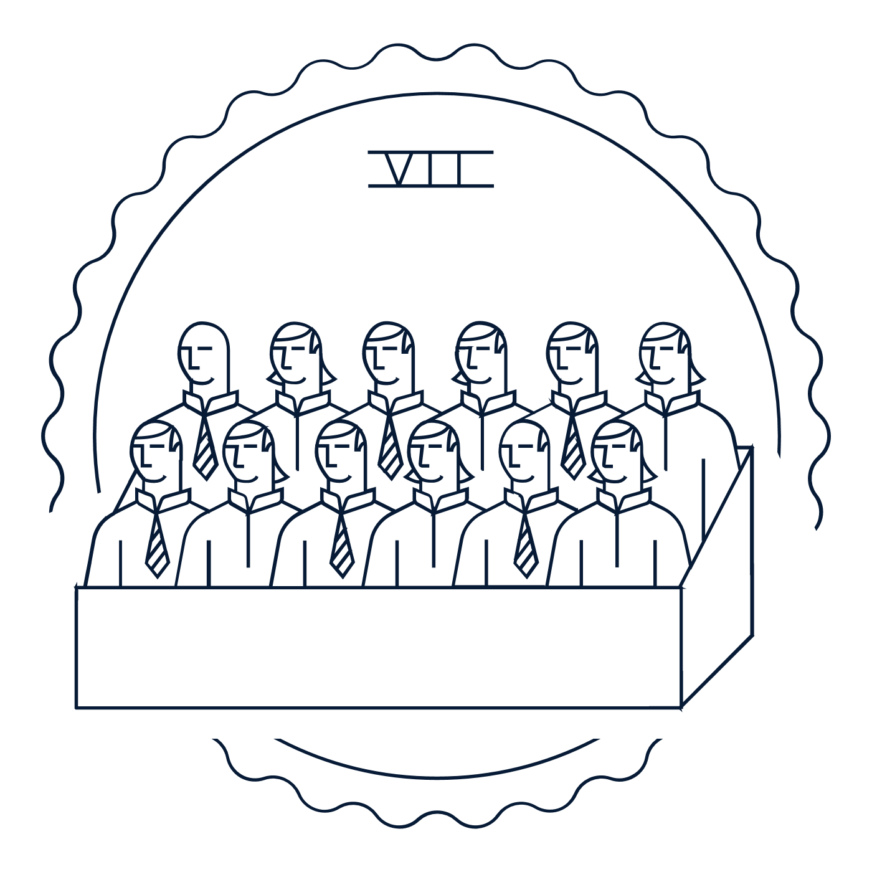 | Text of the Amendment  Common Interpretation
Eighth Amendment  1791 | Text of the Amendment  Common Interpretation
Ninth Amendment  1791 | Text of the Amendment  Common Interpretation
10th Amendment  1791 | Text of the Amendment  Common Interpretation
11th Amendment  1795  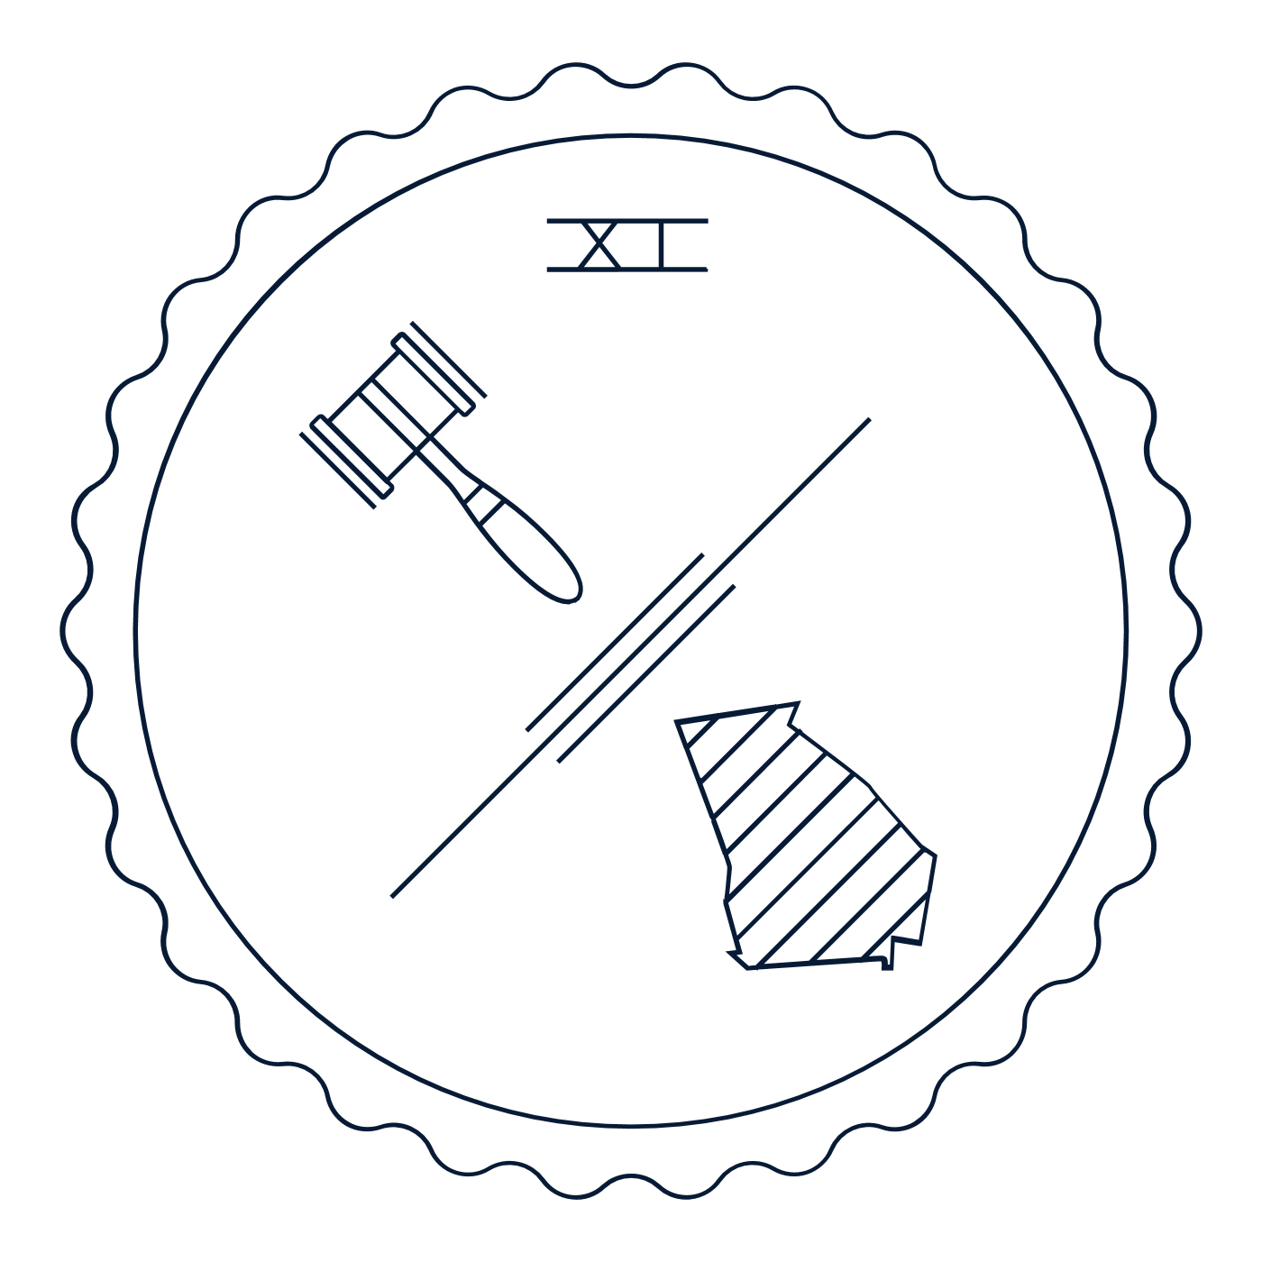 | Text of the Amendment  Common Interpretation
12th Amendment  1804 | Text of the Amendment  Common Interpretation

Reconstruction era amendments: 1865 – 1870 (There was a 60+ year gap between the Founding and Reconstruction eras.)
Gave us three transformational amendments that many scholars argue represent our nation’s “Second Founding.”

Amendment | Read the amendment  on the Interactive Constitution. | Summarize the amendment in your own words. | What are three to five key words or terms associated with this amendment? | What were some factors that led to this amendment being added to the Constitution?
12th Amendment  1804 | Text of the Amendment  Common Interpretation
14th Amendment  1868 | Text of the Amendment  Common Interpretations:  - Citizenship Clause  - Due Process Clause  - Equal Protection Clause  - Enforcement Clause  - Privileges or Immunities Clause
15th Amendment  1870 | Text of the Amendment  Common Interpretation

The Progressive era: 1913 – 1920 (There was a 40+ year gap between the Reconstruction and Progressive eras.)
Gave us the 16th–19th Amendments.

Amendment | Read the amendment  on the Interactive Constitution. | Summarize the amendment in your own words. | What are three to five key words or terms associated with this amendment? | What were some factors that led to this amendment being added to the Constitution?
16th Amendment  1913  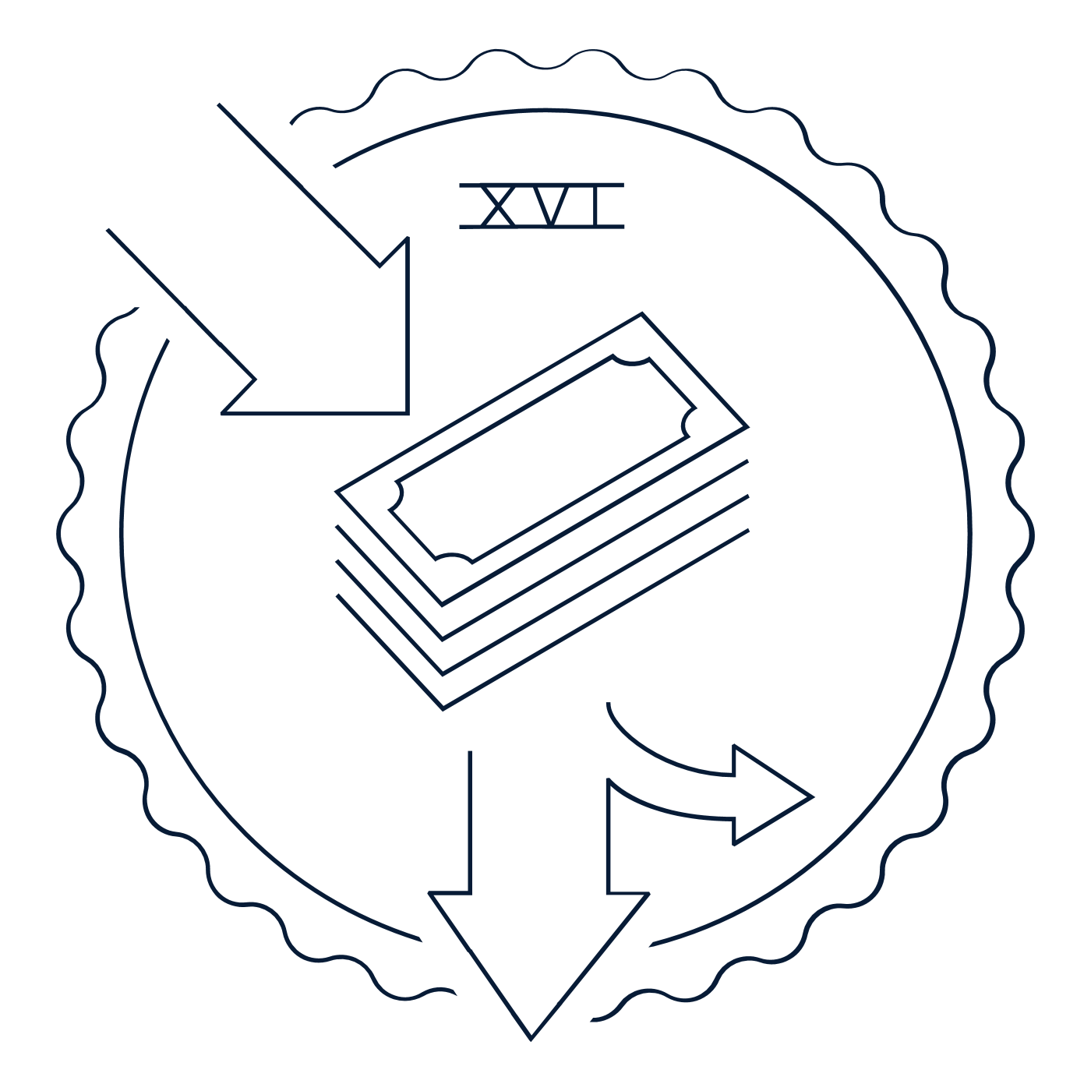 | Text of the Amendment  Common Interpretation
17th Amendment  1913 | Text of the Amendment  Common Interpretation
18th Amendment  1919  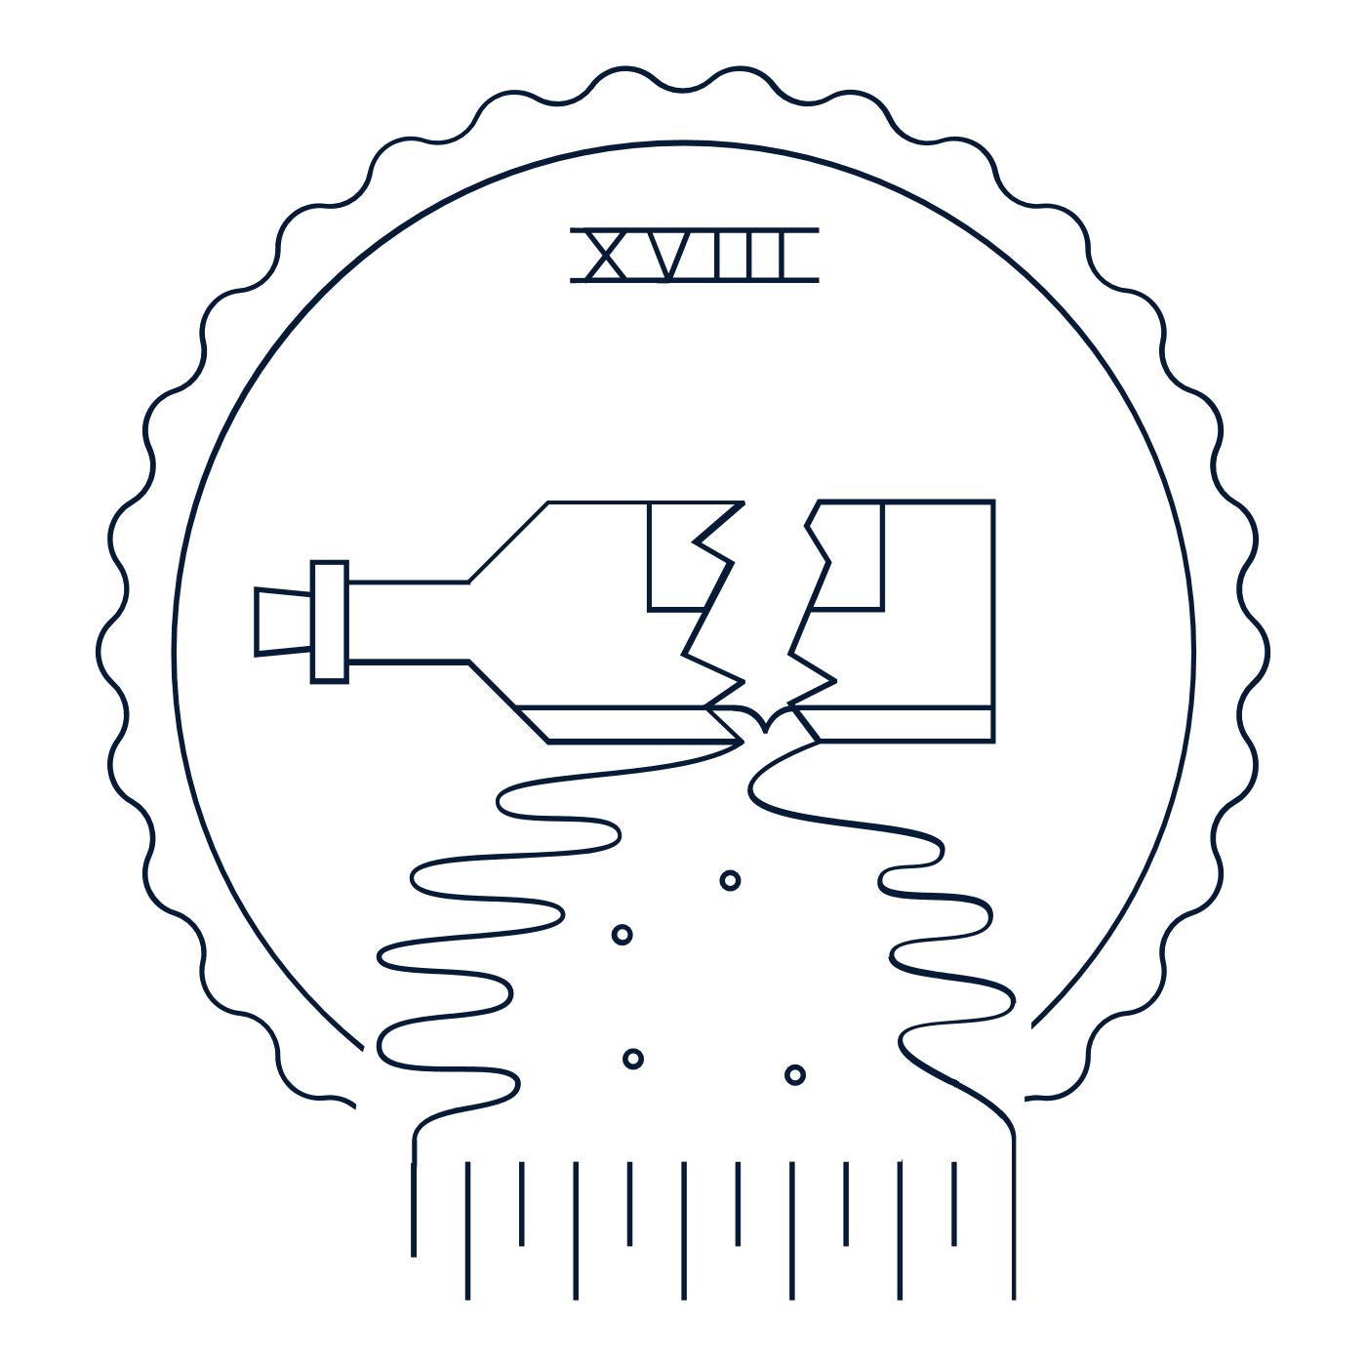 | Text of the Amendment  Common Interpretation
19th Amendment  1920 | Text of the Amendment  Common Interpretation

Modern era: 1933 – 1992 (It’s been over 30 years since the last amendment!)
Added the remaining eight amendments, little by little, between 1933 and 1992.

Amendment | Read the amendment  on the Interactive Constitution. | Summarize the amendment in your own words. | What are three to five key words or terms associated with this amendment? | What were some factors that led to this amendment being added to the Constitution?
20th Amendment  1933 | Text of the Amendment  Common Interpretation
21st Amendment  1933 | Text of the Amendment  Common Interpretation
22nd Amendment  1951 | Text of the Amendment  Common Interpretation
23rd Amendment  1961 | Text of the Amendment  Common Interpretation
24th Amendment  1964 | Text of the Amendment  Common Interpretation
25th Amendment  1967 | Text of the Amendment  Common Interpretation
26th Amendment  1971 | Text of the Amendment  Common Interpretation
27th Amendment  1992 | Text of the Amendment  Common Interpretation

