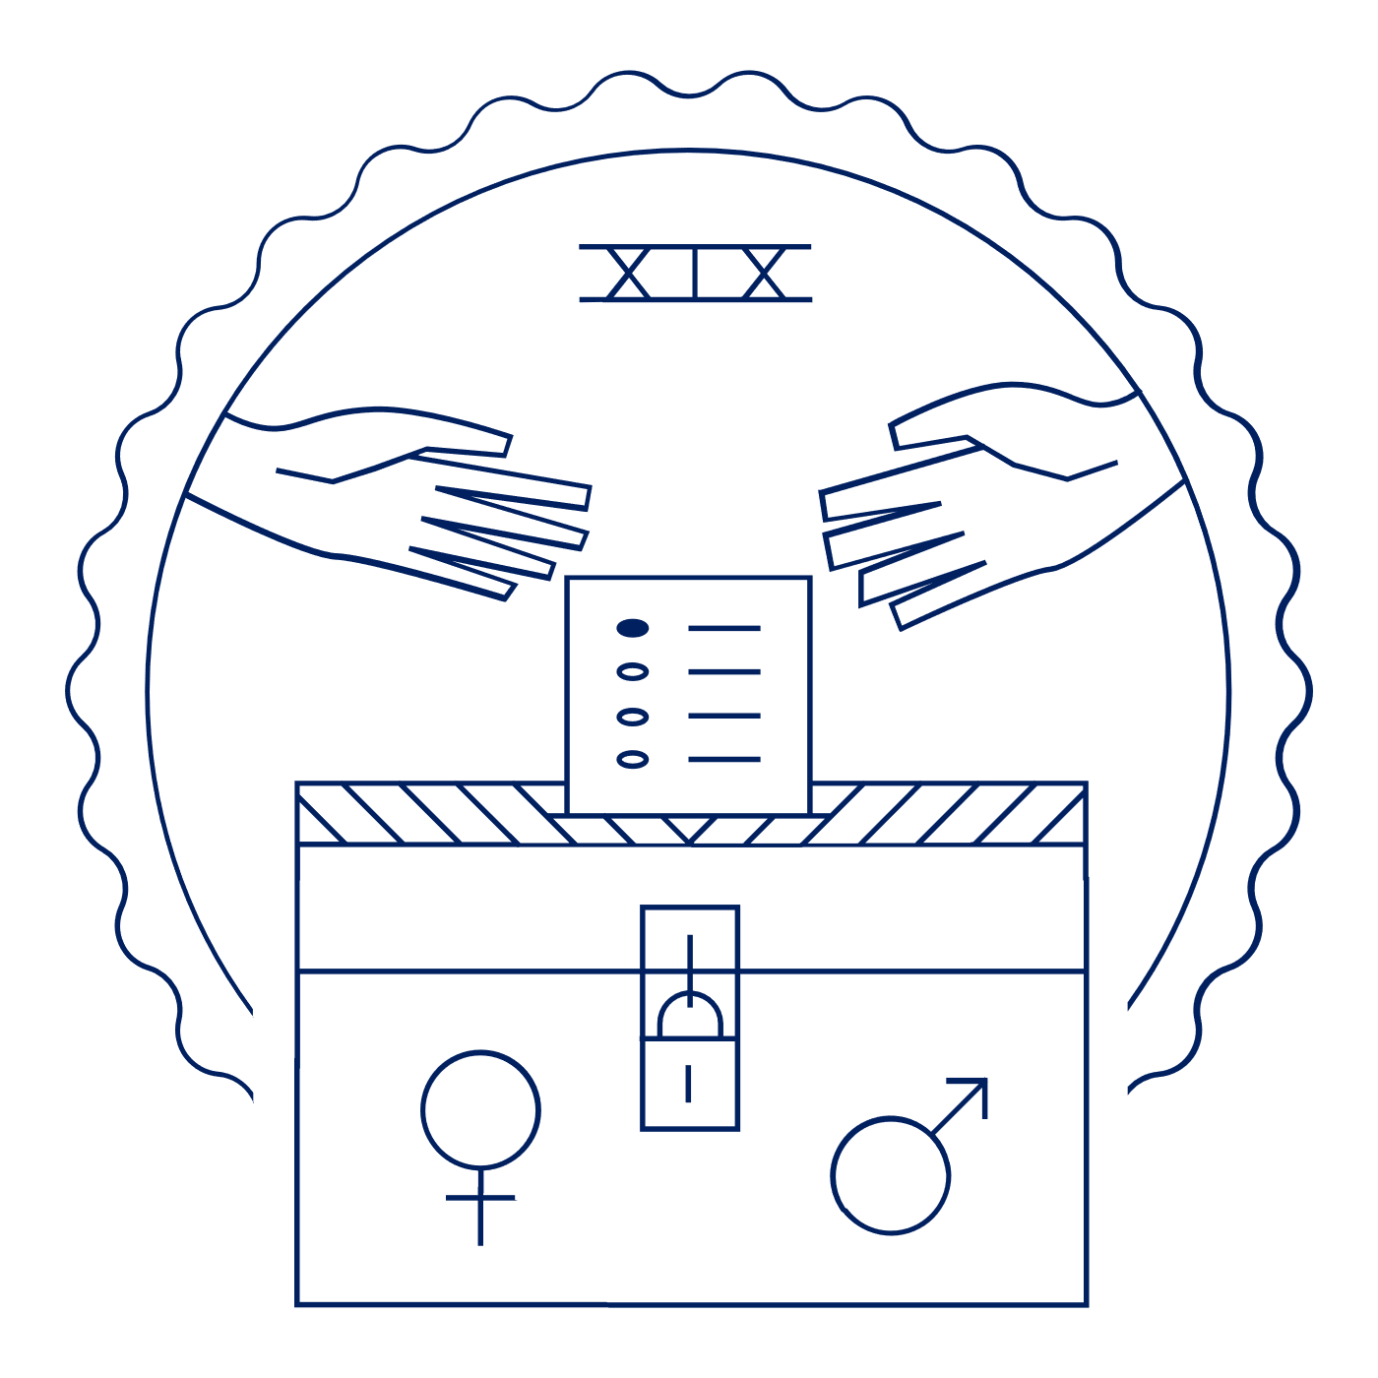
Scholar Exchange: Nineteenth Amendment
Advanced Level
Class Outline and Worksheet

INTERACTIVE CONSTITUTION RESOURCES

- Resources for the 19th Amendment

OVERVIEW

Part I. A Brief Introduction to the 19th Amendment
Part II. History of Women’s Suffrage Before the Civil War
Part III: History of Women’s Suffrage After the Civil War
Part IV: Final Push for a Women’s Suffrage Amendment
Part V: Story of Women’s Suffrage After Ratification

QUESTIONS TO CONSIDER

- What did the Nineteenth Amendment say, and who were some of the key figures who made it a reality?
- What was the Seneca Falls Convention? What was the Declaration of Sentiments? And what did this key moment suggest about the roots of the women’s rights movement in the mid-1800s?
- What were the constitutional arguments advanced by those supporting the women’s vote and those advanced by those opposing it?
- How was the Nineteenth Amendment story an example of federalism in action?
- What did the Nineteenth Amendment settle when it was ratified, and what work remained in the decades ahead?

BIG IDEA

With the Nineteenth Amendment, women won the right to vote. This Amendment grew out of decades of advocacy by the suffragists and their allies. Women’s suffrage began out West in the late 1800s and eventually spread to the rest of the nation—culminating in the ratification of the Nineteenth Amendment in 1920. Even so, it would take many more years—and the hard work of the Civil Rights Movement—to extend voting rights on the ground to all women, including women of color.

NOTES:

PART ONE
What are at least two things that are significant about the text of the 19th Amendment?

PART TWO: WOMEN’S SUFFRAGE BEFORE THE CIVIL WAR
Why were women denied the right to vote in many states during the Founding era?
What is coverture and how does it connect to the broader women’s suffrage movement?
What role did the Seneca Falls Convention play in the larger women’s suffrage movement?

PART TWO: WOMEN’S SUFFRAGE AFTER THE CIVIL WAR
Provide at least two examples of how the ratification of the 14th and 15th Amendments impact the women’s suffrage movement? | Example One:
 | Example Two:

What was the “New Departure”?
What is an example of its use during the women’s suffrage movement?

PART THREE: FINAL PUSH FOR THE WOMEN’S SUFFRAGE AMENDMENT
How did the women’s suffrage movement progress at the:
Individual state level
Why was it able to progress in such a way at the state level?
National level
Why was it able to progress in such a way at the national level?

What was the impact of World War I on the women’s suffrage movement?

PART FOUR: STORY OF WOMEN’S SUFFRAGE AFTER RATIFICATION
Provide information on at least two questions or issues that needed to be addressed after the ratification of the 19th Amendment.

