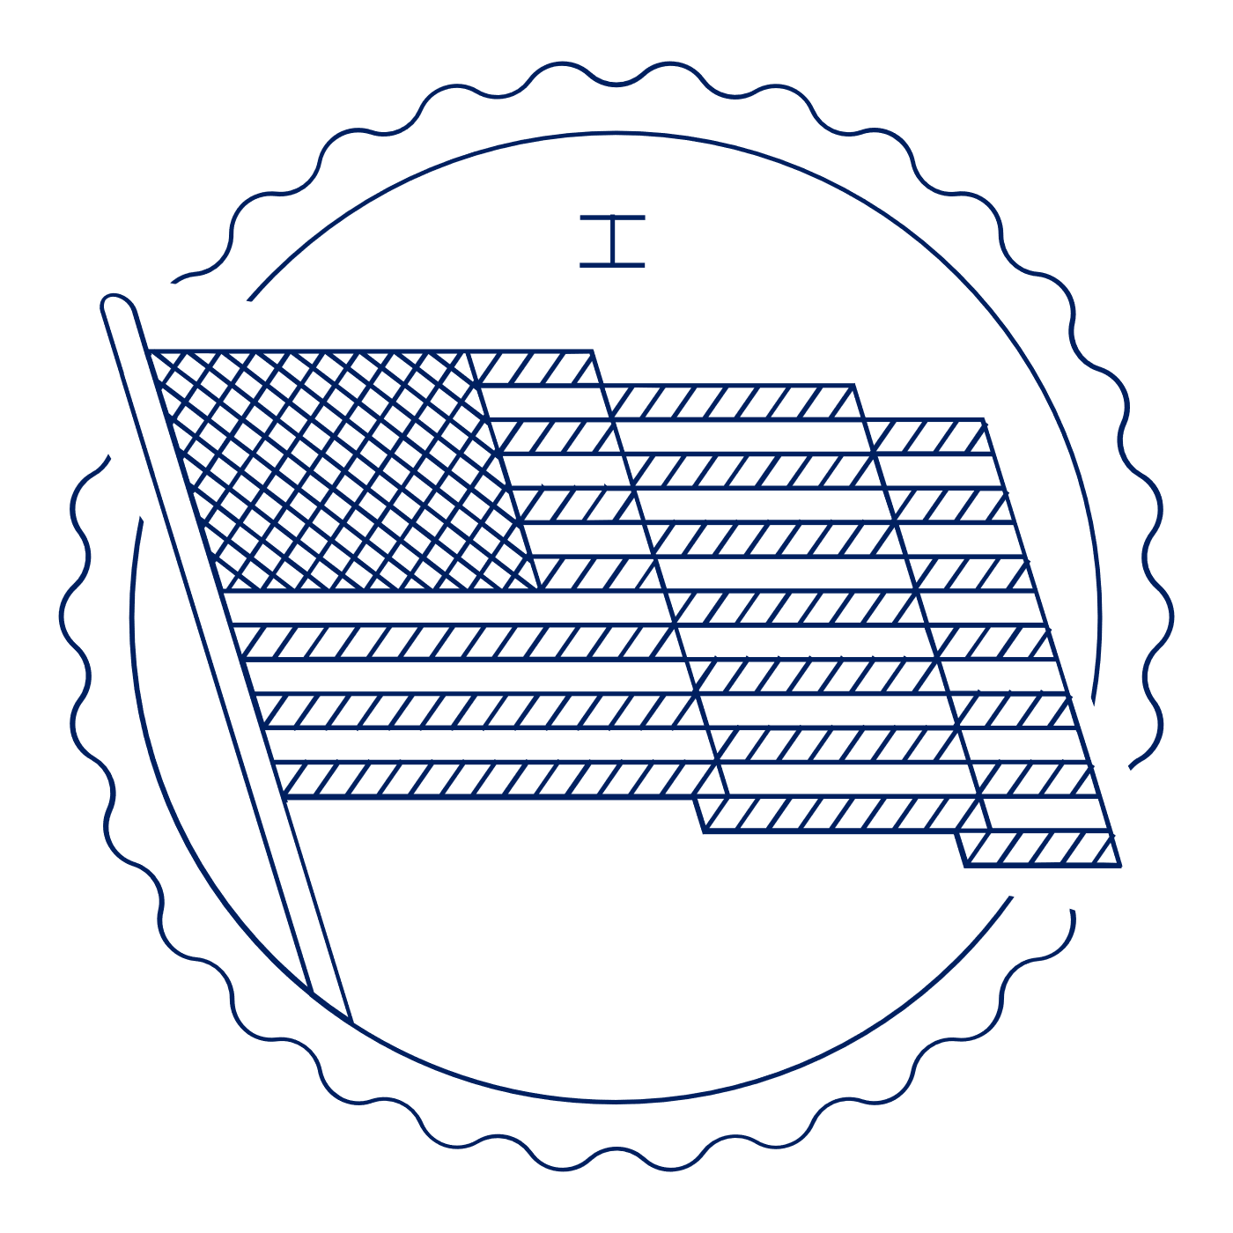
Scholar Exchange: First Amendment – Assembly and Petition Clauses
Introductory Level Class Outline and
Worksheet

OVERVIEW

Part I. The Founding Story of the Assembly Clause
Part II. Historical Examples of Assembly Clause Cases
Part III. The Founding Story of the Petition Clause
Part IV. Historical Examples of Petition Clause Cases

ONLINE RESOURCES

- Resources for the First Amendment and Freedom of Assembly and Petition

QUESTIONS TO CONSIDER

- Why did the Founding generation include assembly and petition rights in the First Amendment?
- How did the Founding generation exercise their assembly and petition rights?
- How have constitutional movements throughout history used assembly and petition rights to push for constitutional change?
- How has the Supreme Court addressed assembly rights over time?
- What are some of the key constitutional debates over assembly and petition rights?
- How can you assert your rights to freedom of assembly and petition today?

BIG IDEA

Throughout American history, minorities and those without power have used assembly and petition rights to find voice and power in their quest for greater freedom and equality. The list includes African Americans, women, unpopular political groups (e.g., abolitionists in the early 1800s), and many others.

PART I. THE FOUNDING STORY OF THE ASSEMBLY CLAUSE
How is the right of assembly unique as compared to the other rights in the First Amendment?
Why is that important?

PART II. HISTORICAL EXAMPLES OF ASSEMBLY CLAUSE CASES
The assembly right has been especially important to groups challenging the status quo. Pick two groups that are discussed and explain how they used the right of assembly.
Group | Examples of the right of assembly

Right of Assembly Today
What are some examples of the right of Assembly today?
What is “time, place, and manner”?

PART III. THE FOUNDING STORY OF THE PETITION CLAUSE
How was the right to petition used in early American history?
Who was able to petition the government?

PART IV. HISTORICAL EXAMPLES OF PETITION CLAUSE CASES
Provide details about two examples of when an individual or a group used the right to petition.
Individual or Group | Examples of the right to petition

Notes and Questions:

