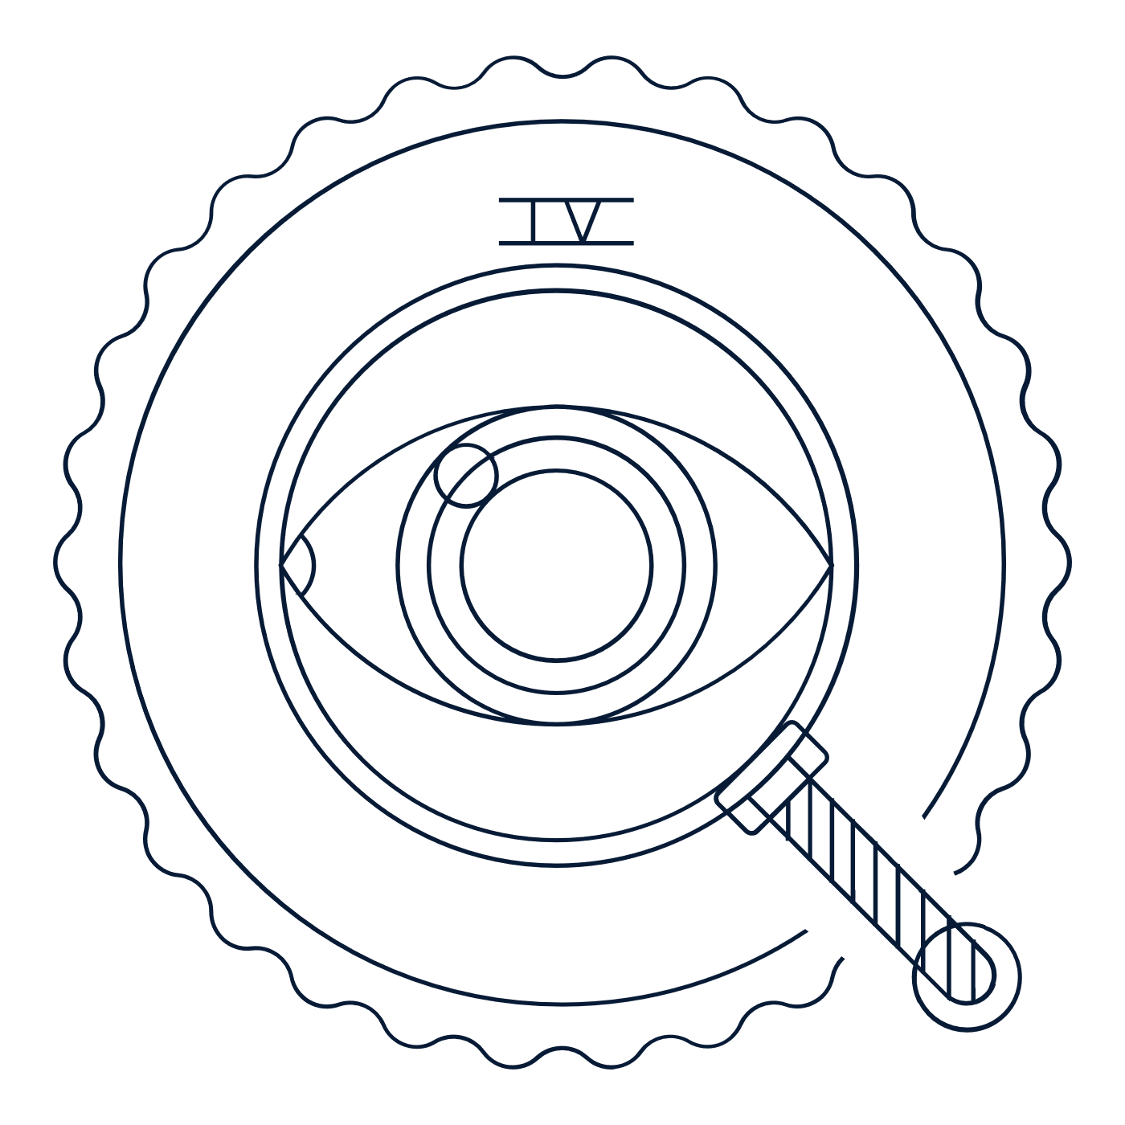
Scholar Exchange: Fourth Amendment
Advanced Level
Class Outline and Worksheet

OVERVIEW

Part I: Introduction to the Constitution’s Text
Part II: Hypothetical
Part III. Founding Stories of the Fourth Amendment
Part IV. Key Fourth Amendment Supreme Court Cases

INTERACTIVE CONSTITUTION RESOURCES

- Resources for the Fourth Amendment

BIG QUESTIONS

- Why did the Framers put the Fourth Amendment in the Bill of Rights?
- What was the Founding generation’s vision for the Fourth Amendment and its protection against unreasonable searches and seizures?
- When does the Fourth Amendment allow the government to search you or seize your property?
- When is a government’s search or seizure “reasonable”?
- How has the Supreme Court interpreted the Fourth Amendment over time? And how has it dealt with the challenge of shaping the Fourth Amendment’s meaning in light of new technologies, especially as it applies to public schools?

BIG IDEA

Before the government can search your home or seize your property, it needs a good reason. This is the big idea behind the Fourth Amendment’s warrant requirement. The government needs particularized suspicion—a reason that’s specific to each suspect—before it can get a warrant. Broadly speaking, our Constitution says that the police should only be able to invade a person’s rights to privacy, property, or liberty if they have a specific reason to think that that specific suspect has done something wrong.

Part One: The Text of the Fourth Amendment
Write down two or three words to help you define these key terms in the Fourth Amendment.
Search

Seizure

Probable Cause

Hypothetical Question: Can the government track you 24 hours a day, 7 days a week, for an entire month, using your cell phone data and location information?
Answer at the beginning of the session | Answer at the end of the session

Part Two: Early Fourth Amendment Cases
Complete the chart based on two early Fourth Amendment cases.
Possible cases include Olmstead v. United States, Katz v. United States, United States v. Miller, or Smith v. Maryland.
Court Case | What was the question? | How did the Court rule?

What is the “third party doctrine”?
How does it connect to questions about the Fourth Amendment?

Part Three: Modern Fourth Amendment Cases
What are some instances when you have an “expectation of privacy”?

Complete the chart with information about Carpenter v. United States.
What was the question? | How did the Court rule? | Why is this case significant?

What are some modern questions about Fourth Amendment rights you can think of?

Notes and questions:

