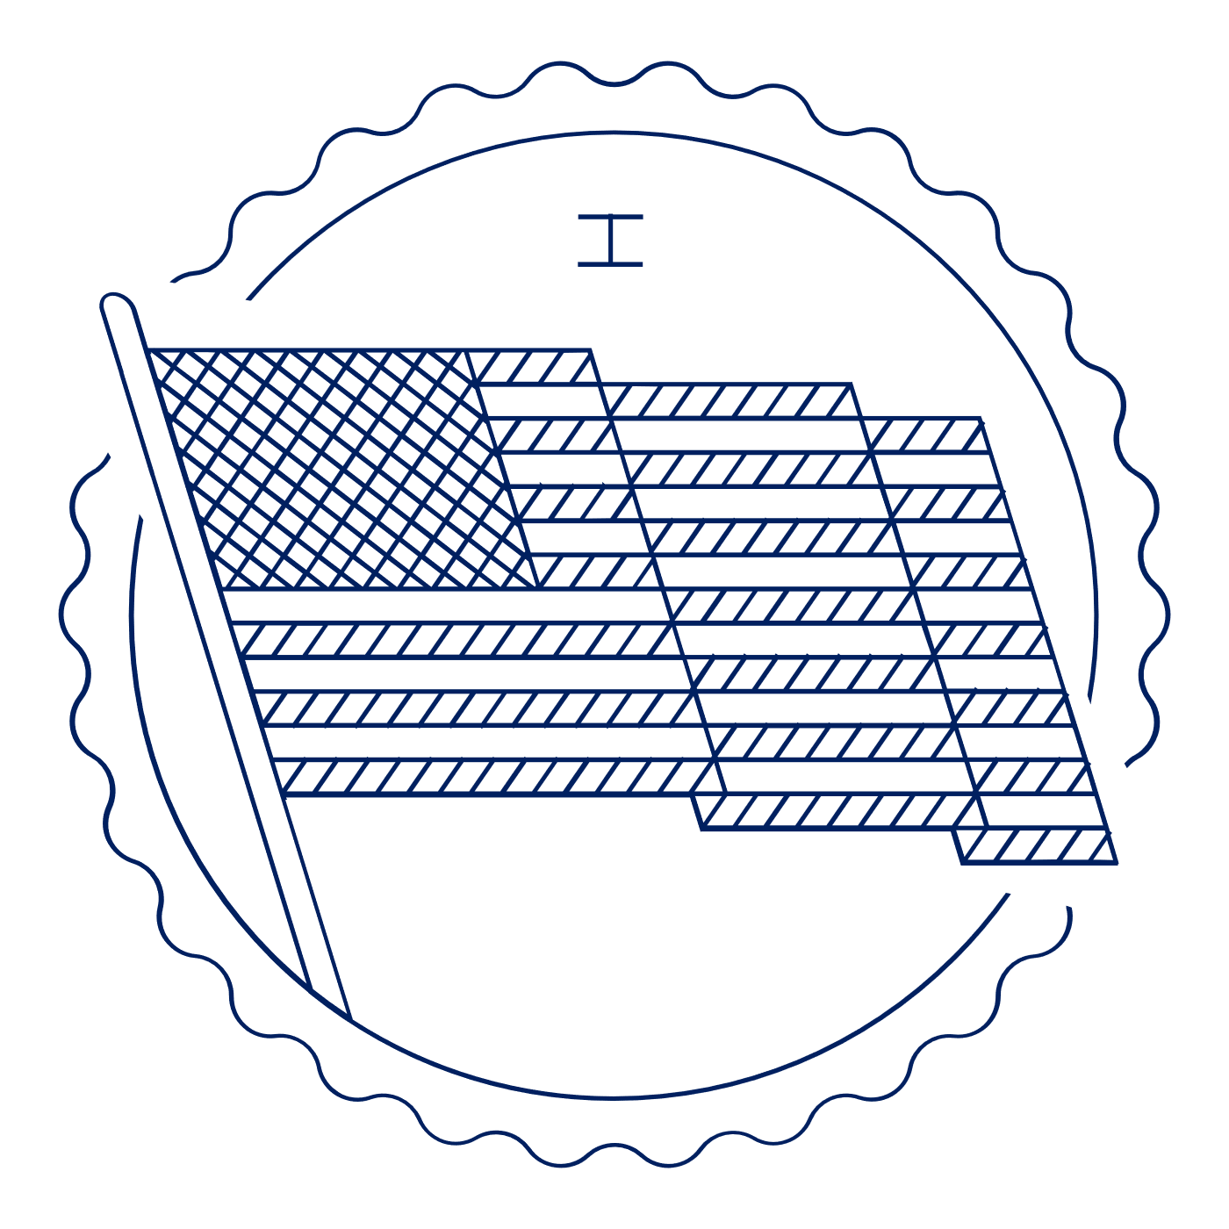
Scholar Exchange: First Amendment — Religion Clauses
Briefing Document

INTERACTIVE CONSTITUTION RESOURCES

- Resources for the First Amendment Freedom of Religion Establishment Clause and Free Exercise Clause.

INTRODUCTION

Big Questions

- Why did the Founding generation write protections for religious liberty into the First Amendment?
- What is the Establishment Clause? What was the Founders’ vision for this provision of the First Amendment? And how has the Supreme Court interpreted it over time?
- What is the Free Exercise Clause? What was the Founders’ vision for this provision of the First Amendment? And how has the Supreme Court interpreted it over time?
- What are some of the most important areas of constitutional debate over religious liberty today?

FIRST AMENDMENT TEXT: A BRIEF INTRODUCTION

Let’s begin—as we always do when interpreting the Constitution—with the Constitution’s text: Congress shall make no law respecting an establishment of religion, or prohibiting the free exercise thereof . . . .

So, there are two religion clauses:
- The Establishment Clause which prohibits the government from establishing or creating a religion in any way—that’s why we don’t have an official religion in the United States.
- And the Free Exercise Clause which gives us all the right to worship God, or not, as we choose. That means the government can’t punish you because of your religious beliefs, or because you don’t belong to a church, or believe in God.

Together, these freedoms make up the foundation of our freedom of conscience—that protects our complete freedom of thought and opinion, and the freedom to worship, or not, as we please.

But how do we know if the government has established a religion? How can we counteract the power of one group, usually the majority, to take away or curtail the rights of a religious minority?

Those questions are at the heart of the First Amendment’s protection of religious liberty, and they remain among the most hotly contested questions in Constitutional law today.
Big Idea

The First Amendment protects religious liberty in two ways. First, it guards against government establishment of religion. And second, it protects the free exercise of religion. Together, these constitutional promises are at the core of our freedom of conscience—the right to freely believe as we wish.

FOUNDING STORY OF THE RELIGION CLAUSES

Why did the Founding generation write the Religion Clauses into the Bill of Rights? To answer this key question, it’s important to remember a bit about the context in colonial America and at the Founding.

American settlers—facing religious oppression at home—crossed the Atlantic in search of religious freedom. The result? A new world defined, in part, by religious diversity.

- We had Puritans in New England.

- Anglicans in the South.

- Quakers and Lutherans in Pennsylvania.

- Roman Catholics in Maryland.

- Presbyterians throughout the middle colonies.

- And Jewish congregations from Newport, Rhode Island, to Savannah, Georgia.

But early America wasn’t just a land of religious diversity. It was also a society with many government-established churches. During colonial America, the Church of England was established by law in all of the Southern colonies. And local Puritan “Congregationalist” establishments held sway in most of New England.

What did these established churches look like?

- Clergy were appointed and overseen by colonial officials.

- Colonists had to pay religious taxes.

- Some even had to attend church services.

- And dissenters were often punished for preaching without a license or refusing to pay church taxes.

At the same time, there were a few states that didn’t have established churches—namely, Delaware, New Jersey, Pennsylvania, Rhode Island, and much of New York.

So, what does this history have to do with the First Amendment?

Following Independence, there was a general consensus that the national government shouldn’t be able to establish a national church. In other words, the national government shouldn’t be in the business of enforcing a particular religious sect or set of beliefs.

And the Establishment Clause, authored by James Madison, reflected this consensus and the underlying belief that religious belief was actually helped by pluralism and a diversity of viewpoints rather than enforced belief.

But, at the Founding, this Clause wasn’t really a triumph for religious liberty. Instead, it was a triumph for federalism. The language of the Clause itself applied only to the national government—calling out Congress.

So, following the ratification of the First Amendment (and its Establishment Clause), the national government couldn’t establish a national church, but states still could. And Congress couldn’t interfere with, or try to dis-establish, churches established by state and local governments. Even so, by 1833, all states had disestablished their state churches.

What about the Free Exercise Clause?

Of course, it’s important to remember that America is a nation defined—in part—by religious diversity, with many dissenters drawn to America by the promise of religious liberty.

Although these new settlers often understood religious liberty more narrowly than we do today, support for protection of some conception of religious liberty was broad and deep.

As a result, it shouldn’t come as a surprise that the Founding generation remained committed to the liberty of conscience.

By the ratification of the U.S. Constitution, freedom of religion was among the most widely recognized natural rights, protected in some fashion by state bills of rights and judicial decisions.

For example, James Madison, main author of the First Amendment, expressed his support for such a provision in Virginia: “It is the duty of every man to render to the Creator such homage, and such only, as he believes to be acceptable to him. This duty is precedent both in order of time and degree of obligation, to the claims of Civil Society.”

This grew out of Madison’s own experience in Virginia as a state legislator in the 1780s. In 1785, during the Virginia legislative debate over whether to continue to fund churches with tax money, Madison wrote an important petition called “Memorial and Remonstrance,” which listed 15 arguments against government support of churches, arguing that religion was a matter of individual conscience and could not be directed by the government in any capacity.

Of course, the original Constitution itself promoted religious liberty, with Article VI banning religious tests for federal office.

But “We the People” also wrote protections for religious liberty in the Bill of Rights when we ratified the Free Exercise Clause as part of the First Amendment in 1791.

In the end, James Madison and the First Congress drafted the First Amendment with this history in mind.

With the First Amendment, Madison and the Framing generation looked to protect the American people from abuses by the newly formed national government. Consistent with America’s religious diversity, the First Amendment was designed to protect the right of individual believers to worship as they liked.

THE ESTABLISHMENT CLAUSE

It took quite some time before the Establishment Clause as we know it today emerged.

For instance, it wasn’t until the 1940s that the Supreme Court finally held that the Establishment Clause applied against state religious entanglements. (This is “incorporation.”) So, we don’t have a national church and no longer have established churches in the states.

What does the Establishment Clause mean today?

Well, there are some easy cases.

- Virtually all jurists would agree that it would violate the Establishment Clause for the government to require church attendance.

- Or for the government to mess with a religious organization’s selection of clergy.

- Or its religious doctrine.

- Or for the government to grant benefits to some religious entities, but not others without some legitimate non-religious justification.

But that’s about it. Many other issues remain hotly contested. And many of these cases lead to 5-4 decisions at the Supreme Court.

Let’s first talk about the legal test that covers the Establishment Clause.

The Lemon Test—Lemon v. Kurtzman (1971)

There’s a legal test the Court has traditionally applied to these cases, and it’s called the Lemon test, named after a 1971 case, Lemon v. Kurtzman.

To pass this test a law has to do three things:
- It has to have a secular legislative purpose
- It’s primary effect has to neither advance nor inhibit religion
- The law can’t cause an excessive entanglement between government and religion.

Now, many Supreme Court Justices have strongly criticized this test, but the Court has never overruled it. At the same time, the Supreme Court does sometimes decide Establishment Clause cases without applying it. And in some specific areas, the Court has also crafted specific, targeted “tests” to replace Lemon.

So, it’s a bit of a mess.

Let’s look at the three most common types of Establishment Clause cases.

Area #1: First, we have aid to religious education or other activities conducted by religious institutions.

In this area, scholars have divided between two opposing interpretations of the Establishment Clause.

One set of scholars argues that the government must be neutral between religious and non-religious institutions that provide education or other social services.

The other set argues for a bright-line rule, arguing that no taxpayer funds should be given to religious institutions if they might be used to communicate religious doctrine.

And the Supreme Court itself has moved between these positions over time. Initially, the Court followed the first approach. Then, in the 1970s and 1980s, it shifted to the second one. And, finally, in more recent years, the Court has moved back to the first approach.

For instance, the Court first upheld state laws allowing students who attend private religious schools to receive transportation (Everson v. Board of Education, 1947).

Then, for roughly fifteen years, the Court tried to draw sharp lines against the use of government money for the religious schools—for instance, banning public school teaching specialists from going to religious schools to provide remedial assistance to students.

However, more recently, the Court has upheld programs that give government money to educational or social programs on a neutral basis—as the Court describes it, “only as a result of the genuine and independent choices of private individuals” (Zelman v. Simmons-Harris, 2002).

And the Court has struck down state laws that keep religious institutions that otherwise qualify for government aid/assistance solely from getting it (Trinity Lutheran Church of Columbia v. Comer, 2017).

Area #2: The second area is government-sponsored prayer.

This is probably the most famous set of cases under the Establishment Clause.

These decisions held it unconstitutional for public schools to lead schoolchildren in prayer or Bible reading, even on a voluntary basis (Engel v. Vitale, 1962; Abington School District v. Schempp, 1963). These cases received a great deal of backlash from the public, but the Court has stood its ground. And it has even gone so far as to extend the prayer ban to graduation ceremonies (Lee v. Weisman, 1992) and football games (Santa Fe Independent School District v. Doe, 2000).

However, in settings involving adults, the Court has generally allowed government-sponsored prayer, upholding legislative prayer (because it was steeped in history) (Marsh v. Chambers, 1983) and approving an opening prayer or statement at town council meetings, where the town represented that it would accept prayers from all faiths (Town of Greece v. Galloway, 2014).

Concerns about coercion (or not) seem to be doing most of the work in these cases—with the Court concluding that young students are much more vulnerable than adults.

Area #3: The final area is government-owned or -sponsored religious symbols.

These cases are also high profile. They involve governmental displays of religious symbols. So, these are the cases involving Ten Commandment displays in public school classrooms, courthouses, or public parks. And nativity scenes in courthouses and shopping districts. And crosses on public land. They remain quite controversial.

In recent years, the Court’s main approach to these cases has often been a sort of “Endorsement Test.”

This test asks the common-sense question of whether a reasonable observer acquainted with the full context would regard the display as the government endorsing religion and, therefore, sending a message of discouragement to other believers and non-believers. So, the Court has rejected taking a “rigid, absolutist” approach in these cases.

The results have varied.

In Lynch v. Donnelly (1984), the Court upheld the display of a nativity scene surrounded by other holiday decorations in the heart of a shopping district, stating that it “engenders a friendly community spirit of good will in keeping with the season.”

But in County of Allegheny v. ACLU (1989), a different set of Justices held that the display of a nativity scene by itself at the top of the grand stairway in a courthouse violated the Establishment Clause because it was “indisputably religious—indeed sectarian.”

And in McCreary County v. ACLU (2005), the Court held that a prominent display of the Ten Commandments at the county courthouse, which was preceded by an official’s description of the Ten Commandments as the “embodiment of ethics in Christ,” was unconstitutional, while on the same day upholding a Ten Commandments monument, which was donated by a secular organization dedicated to reducing juvenile delinquency and surrounded by other monuments on the spacious state grounds. (Van Orden v. Perry, 2005). (Only Justice Breyer was in the majority in both cases.)

Most recently, the Supreme Court upheld a large cross on public lands commemorating veterans of WWI. (American Legion v. American Humanist Association, 2019).

THE FREE EXERCISE CLAUSE

From the beginning, courts have struggled to strike a balance between the religious liberty of believers, who often claim the right to be excused from laws that interfere with their religious practices, and the interests of government.

The Supreme Court has said repeatedly that the government may not compel or punish religious beliefs. In America, people are free to think and believe whatever they please according to the dictates of their conscience.

However, the Free Exercise Clause has never provided absolute protection for religiously motivated conduct. For example, the government is allowed to ban behavior that a certain religion requires like polygamy—that’s marrying more than one person—or the use of hallucinogenic drugs.

The Court has said that the Free Exercise Clause “embraces two concepts—freedom to believe and the freedom to act. The first is absolute but, in the nature of things, the second cannot be.” (Cantwell v. Connecticut, 1940).

And that’s a pretty good way to think about the Court’s application of the Clause over time. And the ongoing debates over how to rule in Free Exercise cases.

Of course, governments don’t usually adopt laws banning or requiring thoughts. Instead, our laws regulate conduct. In other words, actions.

And the Free Exercise Clause is used in a variety of legal challenges.

One is when the government bans behavior that a person’s religion requires.

      - Think polygamy.

      - Or animal sacrifice.

- Or the use of hallucinogenic drugs.

- Or even human sacrifice, for that matter.

A second is when the government requires conduct that a person’s religion bans.

      - Think fighting in a war.

      - Or paying taxes to serve a program that violates your religious beliefs.

- Or taking off your yarmulke.

And a third is when individuals claim that laws burden religious observance. So, think working on the Sabbath.

The Supreme Court first addressed the Free Exercise Clause in a series of cases involving nineteenth-century laws aimed at suppressing the practice of polygamy by members of the Church of Jesus Christ of Latter-Day Saints (LDS), also known as Mormons.

The Court unanimously rejected free exercise challenges to these anti-polygamy laws, holding that the Free Exercise Clause protects beliefs but not conduct.

“Laws are made for the government of actions, and while they cannot interfere with mere religious belief and opinions, they may with practices.” Reynolds v. United States (1878).

The Supreme Court warned that to rule otherwise in a case like Reynolds “would be to make the professed doctrines of religious belief superior to the law of the land, and in effect to permit every citizen to become a law unto himself.”

What followed was one of the most extreme government assaults on religious freedom in American history.

Hundreds of church leaders were jailed, rank-and-file Mormons were deprived of their right to vote, and Congress dissolved the LDS Church and took away most of its property, until the church finally agreed to abandon polygamy.

Reynolds influenced the meaning of the Free Exercise Clause well into the twentieth century.

In 1940, the Court finally extended the Clause to limit state laws and other state actions that burden religious exercise. (Cantwell v. Connecticut, 1940.) (Again, this is “incorporation.”)

In the 1960s and early 1970s, the Court shifted on religious liberty claims, strengthening protection for religious conduct by reading the Free Exercise Clause to protect a right of religious believers to exemption from generally applicable laws which burden religious exercise.

For instance, one key case was Sherbert v. Verner.

There, a state denied unemployment benefits to a woman, a member of the Seventh-Day Adventist Church, who quit her job rather than work on her Saturday Sabbath. The Supreme Court applied its toughest legal test in this case and concluded that the denial of benefits imposed a substantial burden on her religion. The woman had to choose between her income and her faith.

For the Court, the issue was “whether some compelling state interest enforced in the eligibility provisions of the . . . statute justifies the substantial infringement of appellant’s First Amendment right.” The Court said no and concluded that the denial of benefits constituted a violation of the Free Exercise Clause.

We see a similar approach in a case like Wisconsin v. Yoder (1972).

There, the Court concluded that Amish families could not be punished for refusing to send their children to school beyond the age of 14.

The Court reasoned: “The Amish objection to formal education beyond the eighth grade is firmly grounded in [their] religious concepts. They object to high school, and higher education generally, because the values they teach are in marked variance with Amish values and the Amish way of life; they view secondary school education as an impermissible exposure of their children to a ‘worldly’ influence in conflict with their beliefs.”

The Court added: “The record in this case abundantly supports the claim that the traditional way of life of the Amish is not merely a matter of personal preference, but one of deep religious conviction, shared by an organized group, and intimately related to daily living.”

The Court concluded: “The impact of the compulsory-attendance law on respondents’ practice of the Amish religion is not only severe, but inescapable, for the Wisconsin law affirmatively compels them, under threat of criminal sanction, to perform acts undeniably at odds with . . . their religious belief.”

And the “self-sufficient” nature of Amish society made education for 14- and 15-year-old children unnecessary and the two additional years of compulsory education “will not impair the physical or mental health of the child, or result in an inability to be self-supporting or to discharge the duties and responsibilities of citizenship, or in any other way materially detract from the welfare of society.”

So, the Court concluded that there was a constitutional violation.

We’re a long way from Reynolds, right? But then a weird thing happened. The Court backtracked.

Although the Court’s legal test didn’t change, the Supreme Court denied far more religious liberty claims than they granted.

For the most part, these cases followed a familiar pattern: A law applied to everyone in a given jurisdiction; someone came to court and claimed a religious objection to that law; and the court ultimately rejected that challenger’s claim.

The bottom line—whether you were an Amish employer refusing to pay Social Security taxes or an army doctor wishing to wear a yarmulke while on duty, you were probably going to lose your constitutional claim under the Free Exercise Clause.

Then along came Employment Division v. Smith in 1990—a landmark decision that read the Free Exercise Clause narrowly.

The case involved Native Americans dismissed from their jobs for failing a drug test. They had smoked peyote during a religious ceremony. Because of this drug use—religiously motivated or not—Oregon then denied them unemployment benefits.

When they challenged this action on free exercise grounds, the Supreme Court rejected their claim.

However, rather than simply applying the Court’s usual test, Justice Scalia—writing for the majority—traded the traditional test for a clearer rule that was even less protective of religious objectors.

Justice Scalia wrote that the Free Exercise Clause “does not relieve an individual of the obligation to comply with a valid and neutral law of general applicability on the ground that the law proscribes (or prescribes) conduct that his religion prescribes (or proscribes).”

Scalia echoed Reynolds’s concern that religious exemptions permit a person, “by virtue of his beliefs, to become a law unto himself,” contradicting “both constitutional tradition and common sense.” Any religious exceptions to general laws, therefore, must come from the “political process.”

Nevertheless, Smith proved to be controversial. And Congress responded to Scalia’s decision by passing a new law countering it.
In 1993, overwhelming—bipartisan—majorities in Congress passed the Religious Freedom Restoration Act (RFRA), which was signed by President Bill Clinton. This law was meant to restore old protections for religious dissenters—as in, the formal protections that they had before Smith.

RFRA allows courts to exempt a person from any law that imposes a substantial burden on sincere religious beliefs or actions, unless the government can show that the law is the “least restrictive means” of furthering a “compelling governmental interest.” So, it’s a tough legal test.

Congress then passed another law, the Religious Land Use and Institutionalized Persons Act (RLUIPA), which applies the same tough test to state laws affecting prisoners and land use.

These new laws have led to exemptions in a wide range of contexts—from kosher and halal diets for prisoners, to relief from zoning and landmark regulations on churches and ministries, to exemptions from jury service.

Although some exemption claims brought under these religious freedom statutes have been relatively uncontroversial—for instance, the Supreme Court unanimously protected the right of a tiny religious sect to use a hallucinogenic drug banned by federal law and the right of a Muslim prisoner to wear a half-inch beard banned by state prison rules—some involve highly contested moral questions.

For example, the Court by a 5-4 vote excused a commercial family-owned corporation from complying with the Affordable Care Act’s “contraception mandate.” (Burwell v. Hobby Lobby Stores Inc., 2014.)

And following Hobby Lobby and Obergefell, we see new legal flashpoints in conflicts over whether businesses with religious objections may refuse their products and services to same-sex weddings.

Finally, even after Smith, the Free Exercise Clause itself continues to provide protection for believers against burdens on religious exercise from laws that target religious practices for discriminatory treatment.

For example, in Church of the Lukumi Babalu Aye, Inc. v. City of Hialeah (1993), the Court unanimously struck down a local law against the “unnecessary” killing of animals in a “ritual or ceremony.”

This law was directed against the Santeria religion, which uses animal sacrifice as one of its principal forms of worship. After the Santerias said that they were going to set up shop in a Florida city, that city passed a new law prohibiting animal sacrifice, defined as killing animals “not for the primary purpose of food consumption.”

The law only applied to an individual of a group that “kills, slaughters, or sacrifices animals for any type of ritual, regardless of whether or not the flesh or blood of the animal is to be consumed.”

The Supreme Court struck this law down. The Court said that Smith was still good law, but added that Smith’s (easy-to-pass) test didn’t apply in a case like this one—when a law was drawn to apply only to a small and unpopular religious sect.

In that case, the Court would apply a much tougher legal test—in fact, its toughest one.

So, with Lukumi, the Court wrote a strong anti-discrimination principle into Free Exercise law.

In its analysis, the Court looked to the text of the law, which spoke of “sacrifice” and “ritual,” and considered it in context—namely, that it was likely to have been directed at the Santerias and that exceptions were written in for kosher butchers and other non-religious animal killings.

In the Court’s view, the law—unlike the one in Smith—was not neutral. The goal was to suppress a particular religion, and the Court struck it down.

The Religion Clauses remain among the most hotly contested (and debated) areas of constitutional law at the Supreme Court.

For instance, recently, in Espinoza v. Montana Department of Revenue, the Supreme Court struck down Montana’s “no aid” provision, which prevented religious schools and religious parents from receiving public benefits because of the religious nature of the school. The Court ruled that this was a violation of the Free Exercise Clause.

In 2015, the state created a tax credit scholarship system for students to attend private schools called “Big Sky” scholarships. The state directed the program to be administered under the limits of the State Constitution’s “no aid” provision.

This provision had its basis in the late 19th century “Blaine Amendments,” a movement against Catholic schools. The amendment nearly passed Congress in the 1870s and would have banned aid to “sectarian schools,” a word widely understood to refer to Catholic private schools.

The Free Exercise Clause “protects religious observers against unequal treatment” and against “laws that impose special disabilities on the basis of religious status.” Status-based discrimination—punishing the free exercise of religion by disqualifying the religious from government aid—gets the strictest of scrutiny from the Court.

The Court concluded that while states need not give money to private education, once they do, they cannot discriminate solely on the basis of religious belief.

Finally, the Court also recently recognized that the Free Exercise Clause (along with the Establishment Clause) required a religious exemption from an antidiscrimination law that interfered with a church’s freedom to select its own ministers.

The Court said that this situation was different from Smith because it “concerns government interference with an internal church decision that affects the faith and mission of the church itself.” Hosanna-Tabor Evangelical Lutheran Church & School v. E.E.O.C. (2012).

And recently, in Our Lady of Guadeloupe v. Morrisey-Burea, the Court held that the “ministerial exception” prohibited employment discrimination lawsuits for teachers who were not ordained ministers but were engaged in religious instruction.

Today, it remains unclear whether cases like Lukumi and Hosanna-Tabor are narrow exceptions to Smith or foreshadow yet another shift towards a more religious liberty-protective approach to the Free Exercise Clause.

Just last Term, multiple Justices called on the Court to reconsider Smith.

