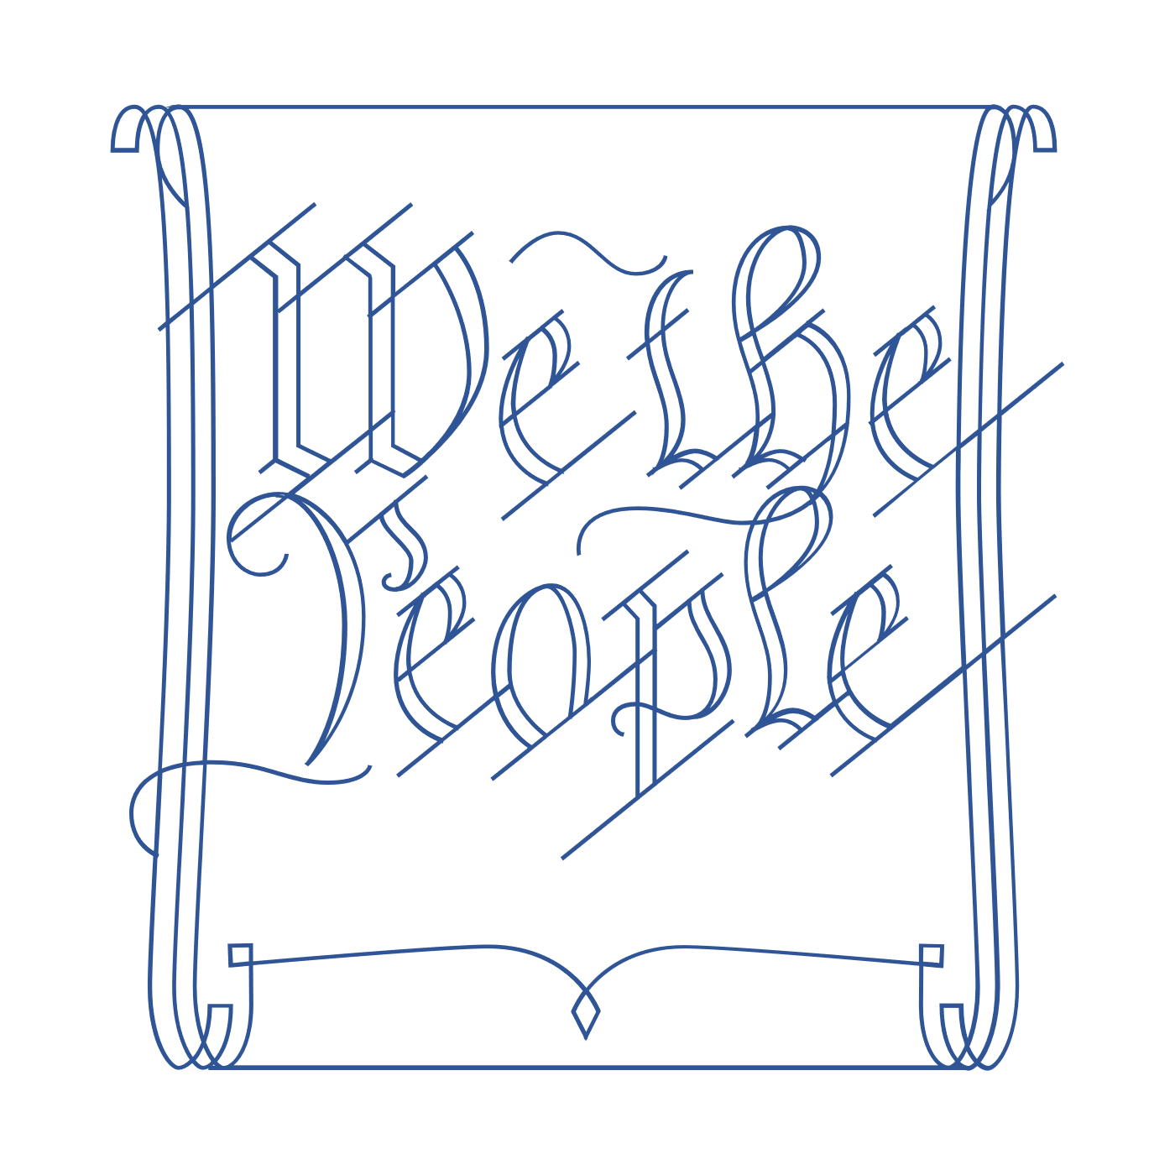
Scholar Exchange: Principles of the American Constitution: 1776-1787
Introductory Level
Class Outline and Worksheet

INTERACTIVE CONSTITUTION RESOURCES

- Resources for Principles of the American Constitution (Articles of Confederation)

OVERVIEW

Warm Up
Part I: ROAD TO THE CONVENTION
Part II: PRINCIPLES OF THE AMERICAN CONSTITUTION

FRAMING QUESTIONS

- Why did the Founding generation decide to write a new Constitution?
- What was the Articles of Confederation, and what sort of national government did it establish?
- What did the Founding generation learn from the state constitutions that the American people wrote before the U.S. Constitution?
- What was Shays’ Rebellion, and how did it influence the Founding generation?
- What key principles underlie the U.S. Constitution, and what sort of system of government did the Founding generation establish?

BIG IDEAS

The Founders were children of the Enlightenment. When crafting a new Constitution, they learned from history and from their own experiences. Between the Declaration of Independence and the U.S. Constitution, the American people were governed at the national level by the Articles of Confederation and at the state level by state constitutions. With the U.S. Constitution, the Founding generation established a new national government. This new government was more powerful than the national government established by the Articles of Confederation, but also one of limited powers.

WARM UP
Why did the Founding generation decide to write a new Constitution? Write down two or three thoughts to answer the question.

PART I: ROAD TO THE CONVENTION
Let’s begin by reviewing some of the key events, and factors, leading to the push for a new Constitution.

The Articles of Confederation
The Articles created a weak central government, or a “league of friendship”.
Why did the Articles of Confederation create such a weak central government?

Shays’ Rebellion
Massachusetts, 1786
What was one cause of Shays’ Rebellion?
What did the Founding generation learn from Shays’ Rebellion?

NOTES:

PART II: PRINCIPLES OF THE AMERICAN CONSTITUTION
We are going to focus on some of the key principles underlying the U.S. Constitution: popular sovereignty, federalism, separation of powers, checks and balances, and republicanism.
Principle | Definition | Key Words, Ideas, or People
Popular Sovereignty | A government that’s driven by us—not a monarch, not the elites, not an aristocracy—but by us, the American people
Federalism | The system of dividing political power between the national government and the states.
Separation of Powers | The distribution of political power between three branches of government.
Checks and Balances | The power granted to each branch of government to check abuses by the other branches.
Republicanism | Civic republican virtue, or the idea that Americans had to choose virtue over vice, reason over passion, and the public good over private self-interest.

FINAL REFLECTION
Before we end the session today, let’s reflect back on the question we asked at the beginning:
Why did the Founding generation decide to write a new Constitution?
Can you add two or three words to your original answer based on what you heard today?

Notes: Take notes here or list all of your questions for the scholar

